# DATE: DECEMBER 7. 2015 CLERK: DIANE ROLLAND

MASSILLON CITY COUNCIL CITY OF MASSILLON, OHIO

TONY M. TOWNSEND, PRESIDENT

COUNCIL CHAMBERS LEGISLATIVE DEPARTMENT ORDINANCE NO. 186 - 2015

BY: ENVIRONMENTAL COMMITTEE

TITLE: AN ORDINANCE amending the following Sections in Chapter 937 Wastewater . Treatment Revenue Fund: 937.05 PAYMENT DATES; PENALTY CHARGE, 937.08

ADMINISTRATION AND DISBURSEMENT OF FUNDS, 937.09 ANNUAL RATES FOR SEWER SERVICE AND 937.10 ADDITIONAL SURCHARGE FOR INDUSTRIAL WASTES of the

Codified Ordinances of the City of Massillon, Ohio, and declaring an emergency.

NOW, THEREFORE, BE IT ORDAINED BY THE COUNCIL OF THE CITY OF MASSILLON, STATE OF OHIO, THAT:

Section 1:

Existing Chapter 937 "WASTEWATER TREATMENT REVENUE FUND" is hereby amended by repealing Chapter 937 as per said Attachment.

Section 2:

The Clerk of Council is authorized to correct any typographical errors discovered herein during or after the pendency or passage of this ordinance. The Clerk of Council is further authorized, in conjunction with the Law Department and the Council President to correct any ministerial or de minimis errors that do not substantially alter the intended results or numerical total sums of this ordinance, during or after the pendency or passage of this ordinance.

Corrected copies are to be sent to all official recipients. Section 3:

This Ordinance is hereby declared to be an emergency measure for the preservation of the public health, safety and welfare of the community. Provided it receives the affirmative vote of two-thirds of the elected members to Council, it shall take effect and be in force immediately upon its passage and approval by the Mayor. Otherwise, it shall take effect and be in force from and after the earliest period allowed by law.

 

# -2- ORDINANCE NO. 186 - 2015



·,' 5.,•.,.'; ·?-"i • "• :.. ... IIyt;-=

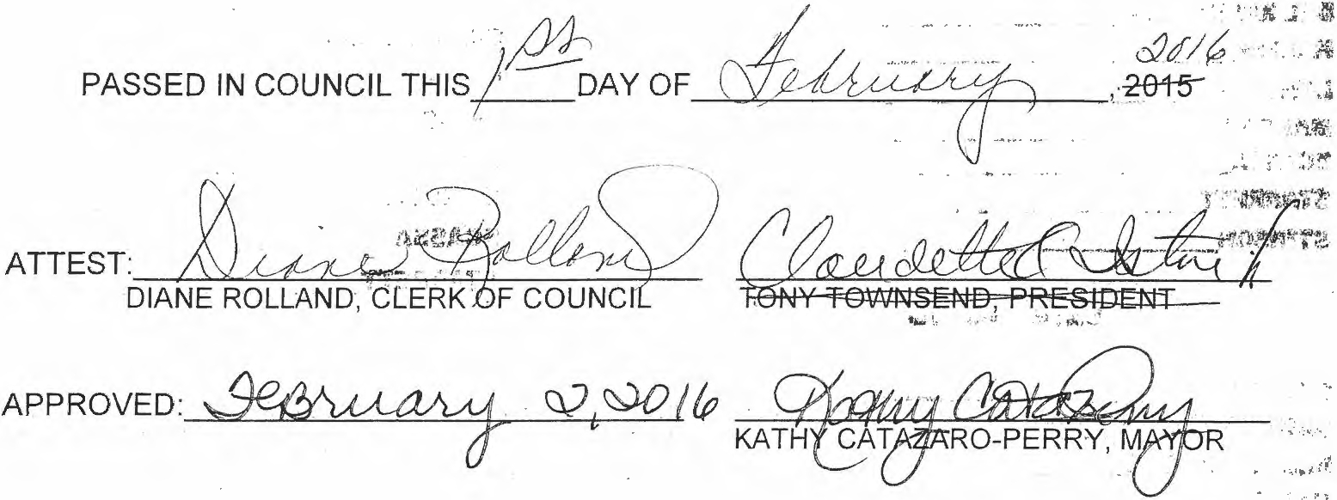

 

*1* •





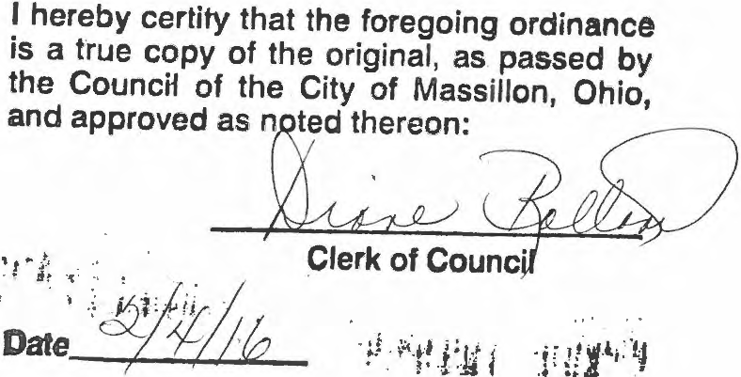 



ATTACHMENT

937.05 PAYMENT DATES; PENALTY CHARGE

1. The charges levied by Section 937.09 shall take effect on April 1, 2016, and shall be billed in four quarterly payments on the first days of January, April, July and October of each year at the end of the period of service rendered , except industrial flow which shall be billed on a monthly basis. All bills shall be payable at the office of the Sewer and Water Department located in City Hall within fifteen days thereafter. All bills not paid within fifteen days after the date when billed shall be subject to a ten percent (10%) penalty.
2. The industrial surcharge levied by Section 937 .10 shall be calculated and billed monthly based on the results of tests and measurements by the City. All bills not paid fifteen days after the date when billed shall be subject to a ten percent (10%) penalty.
   1. ADMINISTRATION AND DISBURSEMENT OF FUNDS
3. The funds received effective January 1, 2016 from the rates and charges hereinafter provided in section
   1. shall be deposited as received with the City Treasurer, who shall keep the same in a separate fund designating the Wastewater Treatment Revenue in the following sub accounts designated as follows:
4. *Wastewater Treatment Fund 2101:*

The revenue deposited in this fund shall be all Stark County revenues received and sixty percent (60%) of all City revenues.

1. *WWT Debt Fund 1305:*

The revenues deposited in this fund shall be all Stark County debt service payments and thirty-nine percent (29%) of all City revenues.

1. *Capital Improvement Fund 1406:*

The revenues deposited in this fund shall be six percent (6%) of all City revenues.

1. *Collection System Improvement Fund 1414:*

The revenues deposited in this fund shall be one hundred percent (l00%) of the capacity charges for new sewer system connections and shall be five percent (5%) of all City revenues.

1. All funds received from the Industrial surcharge hereafter provided in Section 937.10 shall be deposited as received with the City Treasurer, who shall keep the same in the Wastewater Treatment Fund.
2. The proposed rates will be re-evaluated every four (4) years with the next evaluation being in 2019 or as needed.

## 937.09 ANNUAL RATES FOR SEWER SERVICE

1. The following rates are effective April 1, 2016, with respect to any such premises situated within the corporate limits of the City. All Sewer Charges except industrial flow charges will be billed on a Quarterl y basis, with billing in the months of January, April, July and October. Industrial flow charges will be billed on a monthly basis.

## RESIDENTIAL ANNUAL RATE

|  |  |
| --- | --- |
| Single Family Unit | $249.23 |
| Duplex Residential | $498.41 |
| Each Additional Residential Unit | $249.23 |
| Mobile Homes and House Trailers | $249.23 |

**COMJ\1ERCIAL**

(Stores, Resta urants, Bars, Garages, Gas Stations, Professional Offices, Barber/Beauty Shops, Bowling alleys, Theaters, Lodges, Clubs, Business Offices and any other public building)

Church Toilet/Urinal

Food Prep/Bar Sink (Per Bowl) Hair Rinse Sink

Slop Sink Hotel/Motel

Each Bedroom Rooming House

Each Bedroom

Hospitals/N ursing Homes (Per Employee/Patient) Sports Facility/Arena (Per 100 Seats)

Laundromat or Coin Operated Machine Commercial Laundries (By Pound)

$39.91

$166.72

$72.28

$39.91

$42.39

$283.59

$42.39

$283.59

$42.39

$34.90

$5.01

$146.80

$17.47

|  |  |
| --- | --- |
| Car Washes |  |
| Each Single Stall Manual | $295.80 |
| Each Single Stall Automatic | $984.37 |
| Each Drive-Through Automatic | $6,213.56 |

Schools, Public - Private -Day Care Per Student and Employee

Hand Sink Showers

$9.98

$29.93

$106.94

INDUSTRJAL

The following industrial rates apply with respect to any such premises situated within the corporate limits of the City.

|  |  |
| --- | --- |
| Industrial Flow for each Million Gallons | $1,401.25 |
| Industrial Employee (Per Employee) | $42.39 |
| INDIAN RIVER YOUTH FACILITY |  |
| Toilet/Urinal | $166.72 |
| Shower | $106.94 |
| Hand Sink | $29.93 |
| Food Prep Sink (Per Bowl) | $72.28 |

1. The following rates are effective January 1, 2017, with respect to any such premises situated within the corporate limits of the City. All Sewer Charges except industrial flow charges will be billed on a Quarterly basis, with billing in the months of January, April, July and October. Industrial flow charges will be billed on a monthly basis.

RESIDENTIAL ANNUAL RATE

|  |  |
| --- | --- |
| Single Family Unit | $257.95 |
| Duplex Residential | $515.86 |
| Each Addi tional Residential Unit | $257.95 |
| Mobile Homes and House Trailers | $257.95 |

COMMERCIAL

(Stores, Restaurants, Bars, Garages, Gas Stations, Professional Offices, Barber/Beauty Shops, Bowling alleys, Theaters, Lodges, Clubs, Business Offices and any other public building)

Church Toilet/Urinal

Food Prep/Bar Sink (Per Bowl) Hair Rinse Sink

Slop Sink Hotel/Motel

Each Bedroom Rooming House

Each Bedroom

Hospitals/Nursing Homes (Per Employee/Patient) Sports Facility/Arena (Per 100 Seats)

Laundromat or Coin Operated Machine Commercial Laundries (By Pound)

$41.31

$172.55

$74.81

$41.31

$43.88

$293.52

$43.88

$293.52

$43.88

$36.12

$5.18

$151.94

$18.08

|  |  |
| --- | --- |
| Car Washes  Each Single Stall Manual | $306.16 |
| Each Single Stall Automatic | $1,018.82 |
| Each Drive-Through Automatic | $6,431.04 |
| Schools, Public - Private -Day Care |  |
| Per Student and Employee | $10.33 |
| Hand Sink | $30.98 |
| Showers | $110.68 |
| **INDUSTRIAL** |  |

The following industrial rates apply with respect to any such premises situated within the corporate limits of the City.

|  |  |
| --- | --- |
| Industrial Flow for each Million Gallons | $2,389.13 |
| Industrial Employee (Per Employee) | $43.88 |
| **INDIAN RIVER YOUTH FACILITY** |  |
| Toilet/Urinal | $172.55 |
| Shower | $110.68 |
| Hand Sink | $30.98 |
| Food Prep Sink (Per Bowl) | $74.81 |

1. The following rates are effective January I , 2018, with respect to any such premises situated within the corporate limits of the City. All Sewer Charges except industrial flow charges will be billed on a Quarterly basis, with billing in the months of January, April, July and October. Industrial flow charges will be billed on a monthly basis.

## RESIDENTIAL ANNUAL RATE

|  |  |
| --- | --- |
| Single Family Unit | $266.98 |
| Duplex Residential | $533.91 |
| Each Additional Residential Unit | $266.98 |
| Mobile Homes and House Trailers | $266.98 |

**COMMERCIAL** (Stores, Restaurants, Bars, Garages, Gas Stations, Professional Offices, Barber/Beauty Shops, Bowling alleys, Theaters, Lodges, Clubs, Business Offices and any other public building)

|  |  |
| --- | --- |
| Church | $42.75 |
| Toilet/Urinal | $178.59 |
| Food Prep/Bar Sink (Per Bowl) | $77.43 |
| Hair Rinse Sink | $42.75 |

|  |  |
| --- | --- |
| Slop Sink | $45.41 |
| Hotel/Motel | $303.79 |
| Each Bedroom | $45.41 |
| Rooming House | $303.79 |
| Each Bedroom | $45.41 |
| Hospitals/Nursing Homes (Per Employee/Patient) | $37.39 |
| Sports Facility/Arena (Per 100 Seats) | $5.37 |
| Laund romat or Coin Operated Machine | $157.26 |
| Commercial Laundries (By Pound) | $18.72 |
| Car Washes  Each Single Stall Manual | $316.87 |
| Each Single Stall Automatic | $1,054.48 |
| Each Drive-Through Automatic | $6,656.12 |
| Schools, Public - Private - Day Care Per Student and Employee | $10.69 |
| Hand Sink | $32.06 |
| Showers | $114.55 |
| **INDUSTRIAL** |  |

The following industrial rates apply with respect to any such premises situated within the corporate limits of the City.

Industrial Flow for each Million Gallons Industrial Employee (Per Employee)

$2,508.59

$45.41

|  |  |  |
| --- | --- | --- |
| **INDIAN RIVER YOUTH** | **FACILITY** |  |
| Toilet/Urinal |  | $178.59 |
| Shower |  | $114.55 |
| Hand Sink |  | $32.06 |
| Food Prep Sink (Per Bowl) |  | $77.43 |

1. The following rates are effective January 1, 2019, with respect to any such premises situated within the corporate limits of the City. All Sewer Charges except industria l flow charges will be billed on a Quarterly basis, with billing in the months of January, April, July and October. Industrial flow charges will be billed on a monthly basis.

RESIDENTIAL ANNUAL RATE

|  |  |
| --- | --- |
| Single Family Unit | $276.32 |
| Duplex Residential | $552.60 |
| Each Additional Residential Unit | $276.32 |
| Mobile Homes and House Trailers | $276.32 |

COMMERCIAL

(Stores, Restaurants, Bars, Garages, Gas Stations, Professional Offices, Barber/Beauty Shops, Bowling alleys, Theaters, Lodges, Clubs, Business Offices and any other public building)

|  |  |
| --- | --- |
| Church | $44.25 |
| Toilet/Urinal | $184.84 |
| Food Prep/Bar Sink (Per Bowl) | $80.14 |
| Hair Rinse Sink | $44.25 |
| Slop Sink | $47.00 |
| Hotel/Motel | $314.42 |
| Each Bedroom | $47.00 |
| Rooming House | $314.42 |
| Each Bedroom | $47.00 |
| Hospitals/Nursing Homes (Per Employee/Patient) | $38.69 |
| Sports Facility/Arena (Per l 00 Seats) | $5.55 |
| Laundroma t or Coin Operated Machine | $162.76 |
| Commercial Laundries (By Pound) | $19.37 |
| Car Washes |  |
| Each Single Stall Manual | $327.96 |
| Each Single Stall Automatic | $1,091.39 |
| Each Drive-Through Automatic | $6,889.09 |
| Schools, Public - Private - Day Care Per Student and Employee | $11.06 |
| Hand Sink | $33.19 |
| Showers | $118.56 |
| INDUSTRIAL |  |

The following industrial rates apply with respect to any such premises situated within the corporate limits of the City.

|  |  |
| --- | --- |
| Industrial Flow for each Million Gallons Industrial Employee (Per Employee) | $2,62 l.47  $47.00 |
| **INDIAN RIVER YOUTH FACILITY** |  |
| Toilet/Urinal | $184.84 |
| Shower | $118.56 |
| Hand Sink | $33.19 |
| Food Prep Sink (Per Bowl) | $80.14 |

1. For the purpose of determining the factory charge for any given year, the number of persons employed or engaged in services on the premises during the applicable billing period shall be considered to be that number arrived at by averaging over such period the number of such persons thereon on the first day of each of the three calendar months included in such period, which information shall be certified in writing by each employer to the Director of Public Service and Safety.

(f) For the purpose of determining the school charge for any given year, the number of pupils and regular employees in a school year shall be the aggregate number thereof enrolled on January **l,** of the preceding year.

1. The purpose of determining the charge for the hospitals, nursing or convalescent homes and for any

given year, the number of patients, and regular employees during the applicable billing period shall be considered to be that number arrived at the averaging over such period the number of patients, and regular employees therein on the first day of each of the three calend ar months included in such period.

1. The proposed rates will be re-evaluated every four (4) years with the next evaluation being in 2019 or as needed.

## 937.lOADDITIONAL SURCHARGE FOR INDUSTRIAL WASTES

1. Any person, firm or corporation served by a sewer connection which discharges sanitary sewage, industrial wastes, water or other liquids into the wastewater treatment system, which are of unusual strength, volume or character, but acceptable by the City for treatment , shall be subject to an additional surcharge which shall be over and above the rates and charges established by Section 937.09.
2. The surcharge shall be effective if any or all of the following are exceeded :

(l ) A five-day biological oxygen demand (BOD) greater than 300 parts per million (ppm) by weight.

1. Total suspended solids (TSS) greater than 300 parts per million (ppm) by weight.
2. The surcharge shall be calculated and billed monthly, based on the results of tests and measurements made by the City effective April 1, 2016.

Additional surcharge effective April **1,** 2016.

* 1. ) BOD in excess of 300 mg/I $0.223/lb of BOD

(2) TSS in excess of 300 mg/I $0.342/lb of TSS

Additional surcharge effective January I , 2017.

* 1. BOD in excess of 300 mgll $0.230/lb of BOD

(2) TSS in excess of 300 mg/I $0.354/lb of TSS

Additional surcharge effective January 1, 2018.

1. BOD in excess of 300 mgll $0.238/lb of BOD
2. TSS in excess of 300 mg/l $0.366/lb of TSS

Additional surcharge effective January 1, 2019.

(1) BOD in excess of 300 mg/I $0.247/lb of BOD

(2) TSS in excess of 300 mg/I $0.379/lb of TSS

1. When required by the Director of Public Service and Safety, the owner of any property discharging such wastes shall install a suitable chamber with gauging and sampling equipment in the building sewer to permit observation , sampling and measurement of the wastes from his premises. Such chamber and equipment shall be constructed in accordance with plans approved by the Director and shall be installed by the owner at his expense and shall be maintained by him.
2. All measurements tests and analyses of the characteristics of such wastes shall be determined by the City in accordance with the latest edition of the "Standard Methods for the Examination of Water and Sewage'', as prepared, approved and published jointly by the American Public Health Association, the American Water Works Association and the Water Pollution Control Federation.

(f) The strength of the wastes shall be determined from samples taken at the aforementioned chamber at any period or time and of such duration and in such manner as agreed upon between the owner and the City. The results of routine sampling and analysis by the owner may also be used, in determining the amount of the surcharge after verification by the City. The strength so found by analysis shall be used in determining the amount of the surcharge.

1. The City shall have the right to enter and set up, on company property, such devices as are necessary to conduct a gauging and sampling operation and to begin such operation without advance notice to the company. While performing the work, the City will observe all safety rules applicable to the premises, established by the company.

Where a company or premises has security measures in force which require proper identification and clearance before entry into the company or premises is granted, such company or premises shall either make the necessary arrangements with their security guards that upon showing proper identification , personnel from the City will be permitted to enter, without delays, for the purpose of obtaining grab samples of wastes being discharged at the various sampling points; or the company or premises shall install suitable gauging and sampling manholes outside the security limits, which manholes will at all times be immediately accessible to City personnel.

1. Ifa person, firm or corporation disagrees with the analysis on which the surcharge is based, he or it may request, in writing, additional sampling and analysis which shall be conducted in a manner acceptable to the Director of Safety-Service and the Manager of Wastewater Treatment. The cost of such additional sampling and analysis shall be borne in full by the requestor.
2. The proposed rates will be re-evaluated every four (4) years with the next evaluation being in 2020 or as needed.