Client Name: City of Massillon |  |  |  | Project: Sippo Creek Reservoir Dam Lowering |  | Project Phase: N/A
Job No. : 60439145 |  |  |  |  |  |  |  | Consecutive Report No.: 001
Summary of Construction/Operation Activities (Include Additional Sheets as Necessary):
JCB 214 backhoe delivered to site today.

Summary of Daily Observations (Include any Problems and Resolutions):
Walk around dam to take pictures of pre-construction conditions.

Preconstruction notes (see site sketch for approximate locations):

- The existing pile of blocks removed from the dam (near the brick building) begins approximately 56 ft from the inside edge of the west endwall. The nearest blocks stacked two courses high are approximately 61 ft from the inside edge of the endwall.
- The orange construction fence surrounding the pile of blocks begins approximately 52 ft from the inside edge of the west endwall.
- The northeast corner of the gazebo which has newer banisters is damaged.
- The southeast corner of the gazebo is missing banisters.
- A large animal hole exists in the ground to the west of the gazebo. This is a potential tripping hazard.
- The lake drain has a diversion pipe prior to the gate valve. This pipe goes into the west creek bank near the gazebo. It may be related to the metal standpipe.

Discussion with contractor

- Mobilization will continue throughout the week as equipment is brought in from other project sites.
- An orange mesh construction fence will be installed to create an exclusion zone. It will run on the west bank from the gazebo to the light pole on the west bank, and on the east bank from the tree closest to the spillway around the work area.
- The diversion pipe attached to the lake drain will need to be removed to install riprap, but the lake drain will remain.
- Excavation is scheduled to begin Monday, February 5 with the stripping and stockpiling of topsoil on the east side of the dam.

Stormwater Management, Erosion & Sediment Controls Observations (Include Sketches and Additional Sheet as Necessary):
none
Summary of Incidents, Accidents, or Health and Safety Issues:
none

Directives Given / Approvals Provided: |  |  |  |  | Material Description |  | Today’s Quantity: |  | Cumulative Quantity:
Surveyor’s Activities: |  |  |  |  | Visitors: |  | Construction Materials/Items Installed:
Weather: | AM: Partly Cloudy |  | PM: -- |  | Contractor Started Work: 12:05p |  | Field Representative Started Work: 10:20a
Temperature: | AM: 31 °F |  | PM: -- °F |  | Contractor Stopped Work: 12:45p |  | Field Representative Stopped Work: 12:45p
Field Representative: Shane Lyons |  |  |  |  |   Field Representative’s Signature:  |  | Date: 1/30/2018
Reviewed by: Stephen Walker, P.E. |  |  |  |  | Reviewer’s Signature: |  | Date: Click here to enter a date.

Photography Log
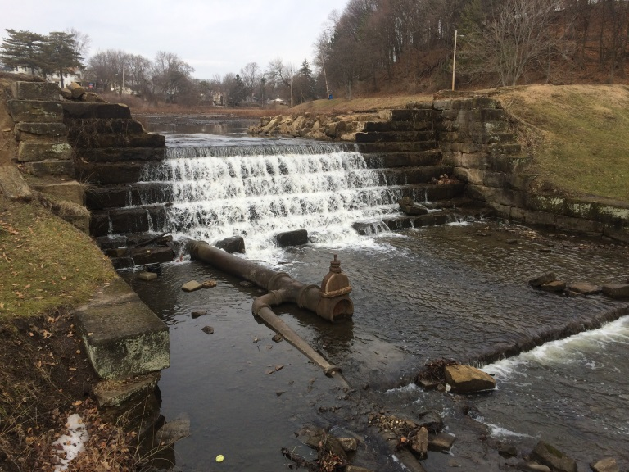 | 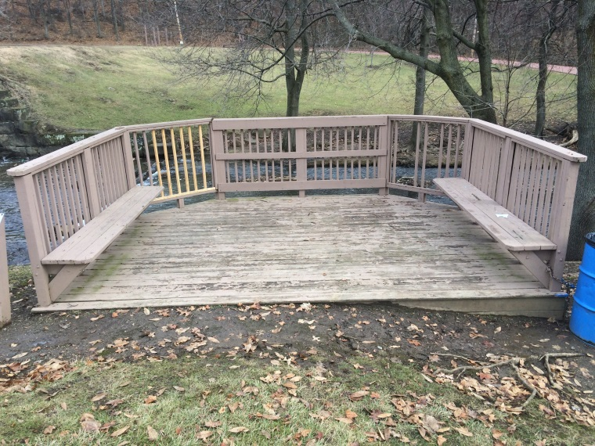
Location: Standing on gazebo looking at dam spillway  Description: Dam prior to construction activities. Dam previously lowered several courses. Lake drain pipe shown. | Location: Entrance to gazebo  Description: Gazebo prior to construction activities. Northeast corner of gazebo is damaged, and southeast corner is missing banisters.
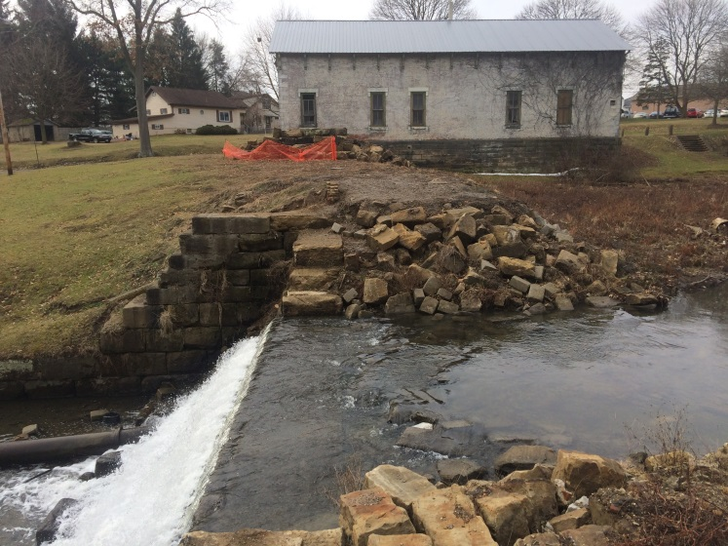 | 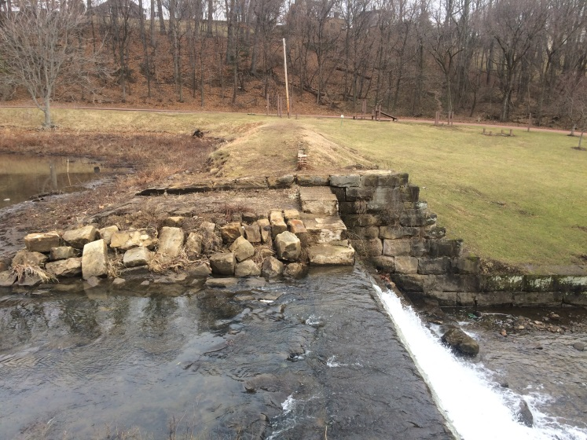
Location: Standing on east endwall looking west  Description: Spillway and approach prior to construction activities. Existing building and stone block pile shown in background. Brick cutoff wall inside dam is partially exposed. | Location: Standing on west endwall looking east  Description: Spillway and approach prior to construction activities. Brick cutoff wall inside dam is partially exposed.

Photography Log
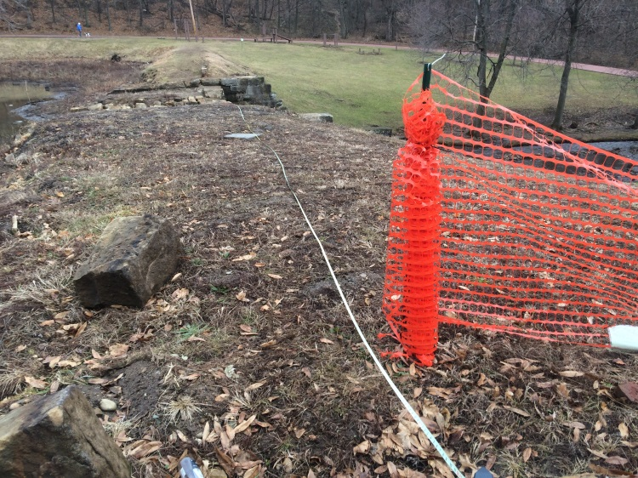 | 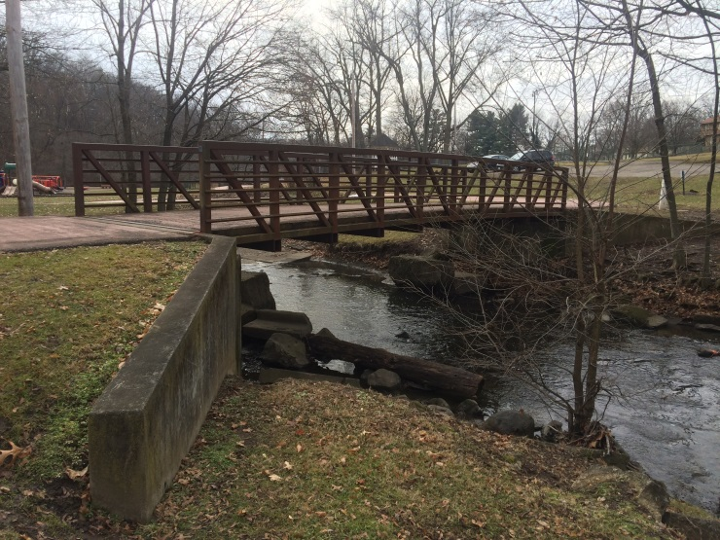
Location: Existing stone pile, looking east  Description: The orange construction fence is approximately 52 ft from the inside edge of the west endwall. The first block is approximately 56 ft from the inside edge of the west endwall. | Location: Standing on northeast side of pedestrian bridge, looking southwest  Description: Pedestrian bridge prior to construction activities.
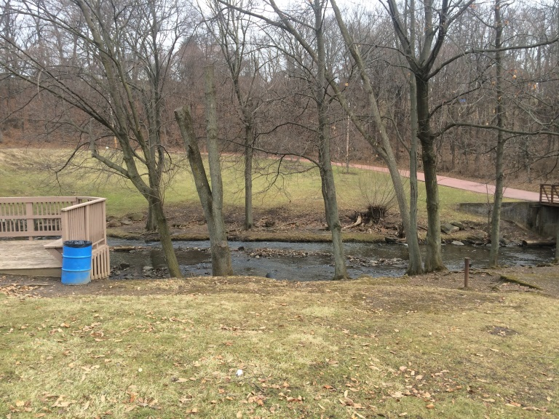 | 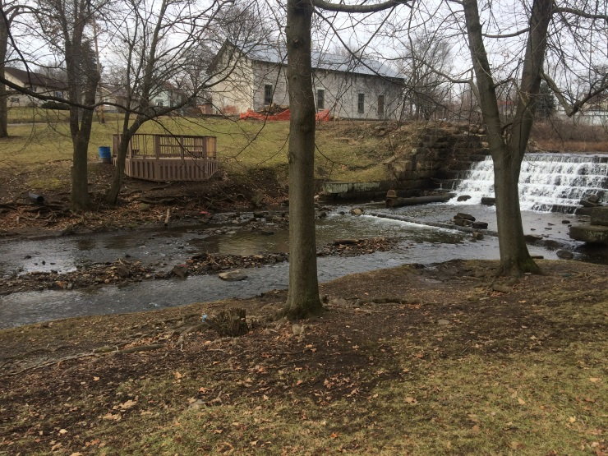
Location: Standing near existing tree, looking east  Description: West bank of creek, downstream of dam. | Location: Standing on stone pavers, looking northwest  Description: East bank of creek, downstream of dam.

Photography Log
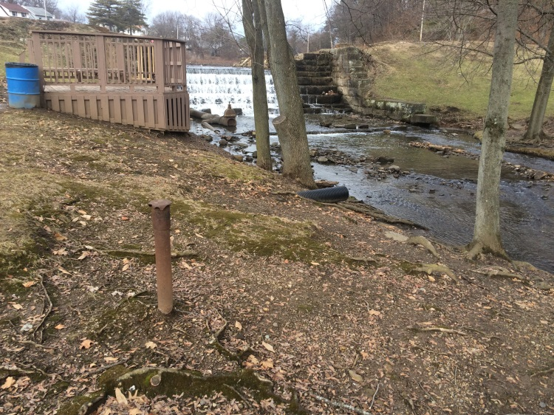 | 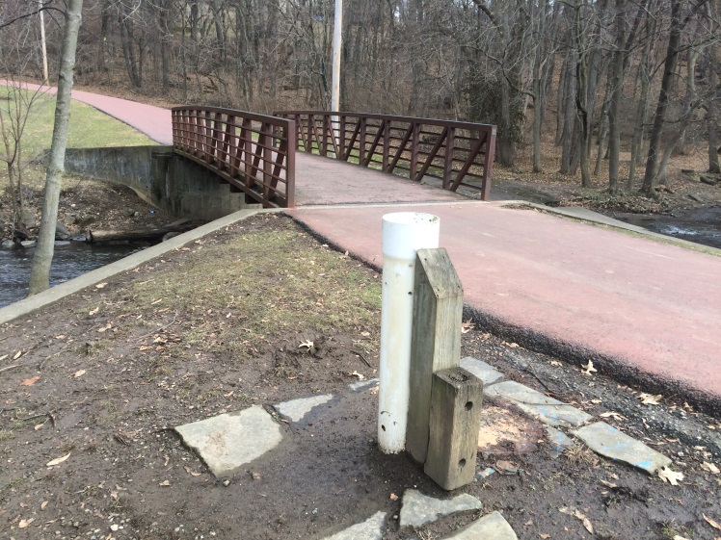
Location: Between gazebo and pedestrian walkway, looking north  Description: Metal standpipe and corrugated plastic pipe. | Location: Standing on northwest side of pedestrian bridge, looking southeast  Description: Plastic standpipe.
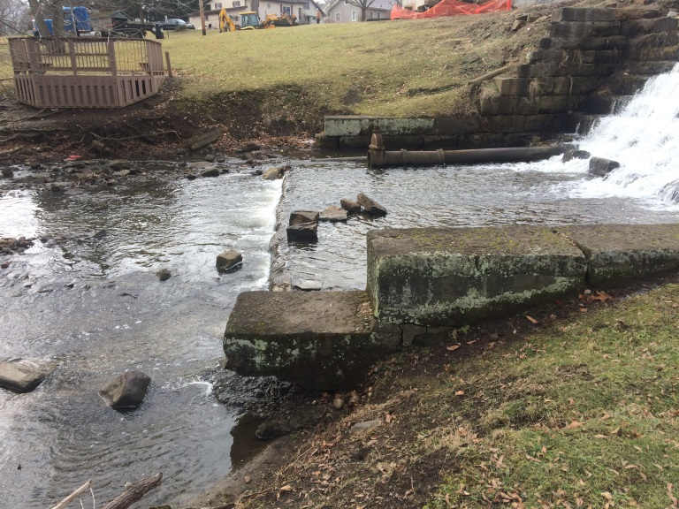 | 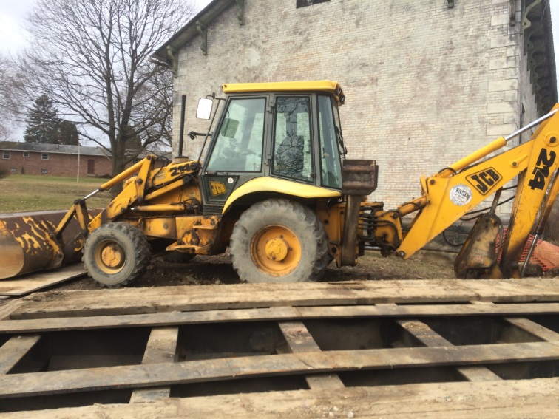
Location: East endwall at bottom of spillway  Description: Lowest block of east endwall has been undercut and eroded and is now cantilevered. | Location: Surface lot south of existing building  Description: JCB 214 backhoe brought to site.

Sketches
