Client Name: City of Massillon |  |  |  | Project: Sippo Creek Reservoir Dam Lowering |  | Project Phase: N/A
Job No. : 60439145 |  |  |  |  |  |  |  | Consecutive Report No.: 002
Summary of Construction/Operation Activities (Include Additional Sheets as Necessary):
none
Summary of Daily Observations (Include any Problems and Resolutions):
Walk around dam to take pictures of mobilization activities.

Orange mesh construction fence installed on west side of dam from southwest corner of existing building, wrapping around light pole, and continuing to northwest corner of gazebo. Orange mesh construction fence installed on east side of dam from about halfway between spillway and pedestrian bridge, following curve of walkway and terminating at the former waterline of the reservoir.

John Deere 200 LC excavator parked outside of the construction fence near the building.

Stormwater Management, Erosion & Sediment Controls Observations (Include Sketches and Additional Sheet as Necessary):
none

Summary of Incidents, Accidents, or Health and Safety Issues:
none

Directives Given / Approvals Provided: |  |  |  |  | Material Description |  | Today’s Quantity: |  | Cumulative Quantity:
Surveyor’s Activities: |  |  |  |  | Visitors: |  | Construction Materials/Items Installed:
Weather: | AM: -- |  | PM: Cloudy |  | Contractor Started Work: -- |  | Field Representative Started Work: 3:15p
Temperature: | AM: -- °F |  | PM: -17 °F |  | Contractor Stopped Work: -- |  | Field Representative Stopped Work: 4:30p
Field Representative: Shane Lyons |  |  |  |  |   Field Representative’s Signature:  |  | Date: 2/2/2018
Reviewed by: Stephen Walker, P.E. |  |  |  |  | Reviewer’s Signature: |  | Date: Click here to enter a date.

Photography Log
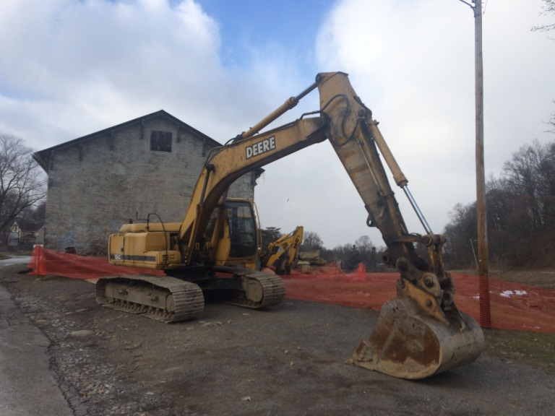 | 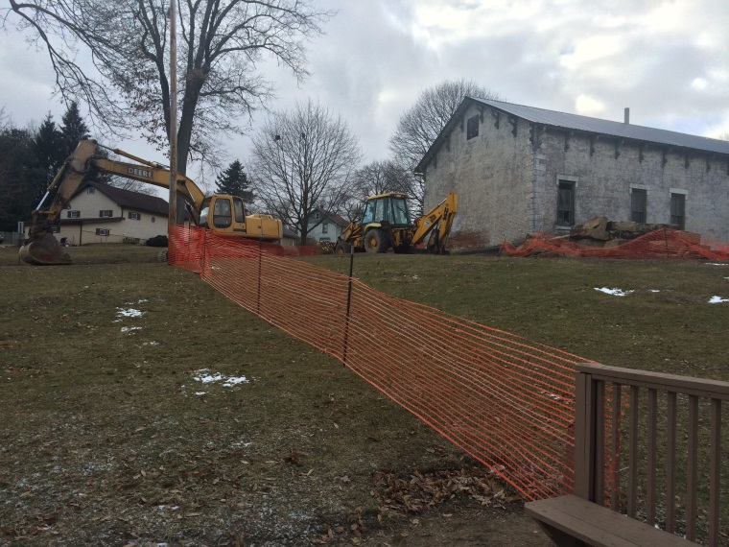
Location: Standing on Reservoir Dr. NE looking north  Description: John Deere 200 LC excavator. Orange mesh construction fence runs from southwest corner of building around light pole. | Location: Standing in gazebo looking west  Description: Orange mesh construction fence runs from light pole to northwest corner of gazebo.
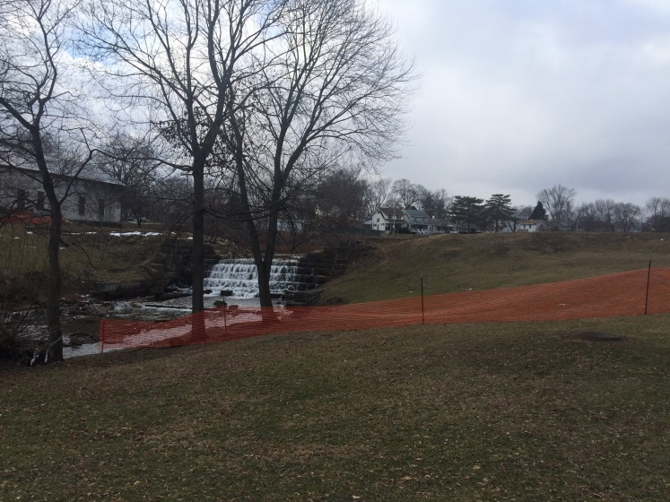 | 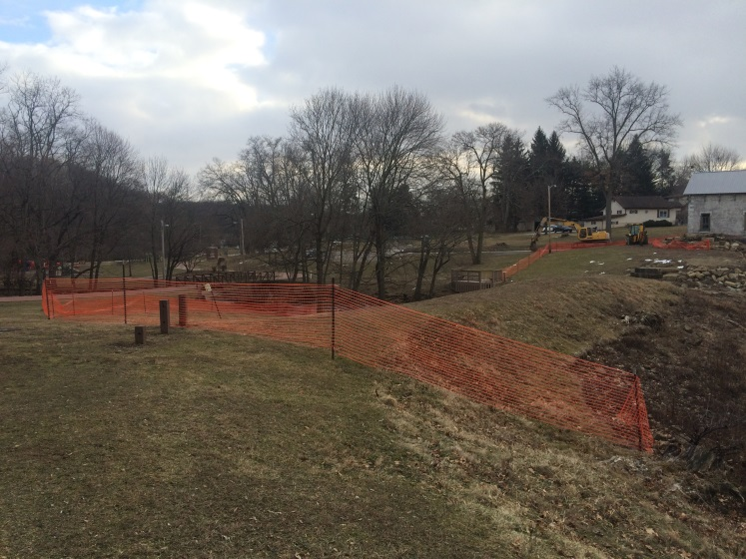
Location: Standing on pedestrian walkway looking northwest  Description: Orange mesh construction fence begins on east side of Sippo Creek. | Location: Standing on pedestrian walkway near dam looking west  Description: Orange mesh construction fence ending at former waterline of reservoir.

