Client Name: City of Massillon |  |  |  | Project: Sippo Creek Reservoir Dam Lowering |  | Project Phase: N/A
Job No. : 60439145 |  |  |  |  |  |  |  | Consecutive Report No.: 003
Summary of Construction/Operation Activities (Include Additional Sheets as Necessary):
Silt fencing was installed along the construction fence on both sides of the creek. The snow and topsoil within the work area were stripped and stockpiled on both sides of the creek. The dam was excavated to approximate design grades and the spoils were placed in low areas on the east side of the existing building and in the southeast corner of the reservoir to bring the slopes to a mowable grade. The sediment surrounding the inlet of the lake drain was excavated and the drain was opened to divert water off of the spillway. Sandstone blocks from both endwalls were removed and stockpiled outside of the limits of proposed grading.

Summary of Daily Observations (Include any Problems and Resolutions):
John Deere 450C LC excavator was delivered to the site on Sunday. John Deere 35D mini excavator was delivered to the site today. The pipe that splits off from the lake drain does so before the gate valve. This pipe will need to be cut and have a valve installed on it. The large bucket on the 450C LC excavator broke on a rock at the end of the day and was taken back to the Contractor’s shop for repairs.

Stormwater Management, Erosion & Sediment Controls Observations (Include Sketches and Additional Sheet as Necessary):
Silt fencing installed. See construction summary for locations.

Summary of Incidents, Accidents, or Health and Safety Issues:
Several journalists visited the site to investigate the construction and entered the construction. They were directed to stay outside of the construction fence.

Directives Given / Approvals Provided: |  |  |  |  | Material Description |  | Today’s Quantity: |  | Cumulative Quantity:
Place spoils on slope in SE corner of reservoir
Place spoils along E side of building
Surveyor’s Activities: |  |  |  |  | Visitors: |  | Construction Materials/Items Installed:
 |  |  |  |  | Steve Pedro – City of Massillon |  | Silt fence
 |  |  |  |  | Greg McCue – City of Massillon
 |  |  |  |  | Josh Garland – ODNR
Weather: | AM: Mostly Cloudy |  | PM: Partly Cloudy |  | Contractor Started Work: 8:25a |  | Field Representative Started Work: 7:10a
Temperature: | AM: 11 °F |  | PM: 19 °F |  | Contractor Stopped Work: 3:30p |  | Field Representative Stopped Work: 3:45p
Field Representative: Shane Lyons |  |  |  |  |   Field Representative’s Signature:  |  | Date: 2/5/2018
Reviewed by: Stephen Walker, P.E. |  |  |  |  | Reviewer’s Signature: |  | Date: Click here to enter a date.

Photography Log
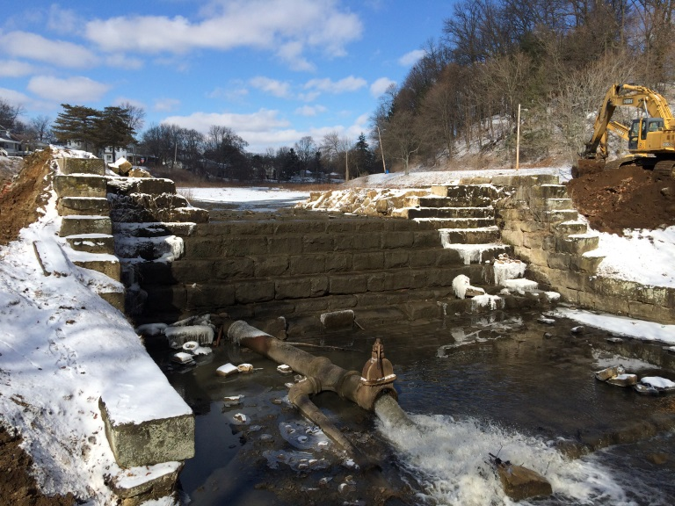 | 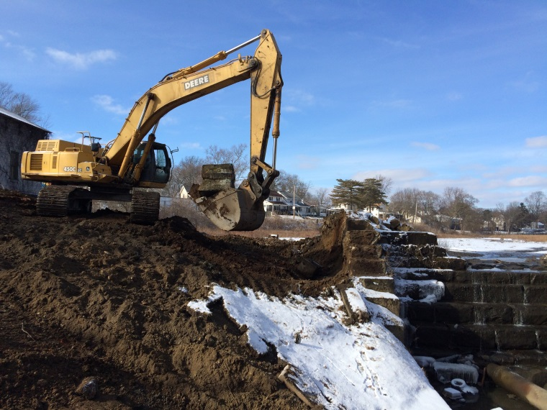
Location: Standing on gazebo looking at dam spillway  Description: Lake drain pipe open and containing all flow from Sippo Creek. No water flowing over spillway. | Location: Bottom of west endwall looking upstream  Description: Sandstone blocks being removed from west endwall with 450C LC excavator.
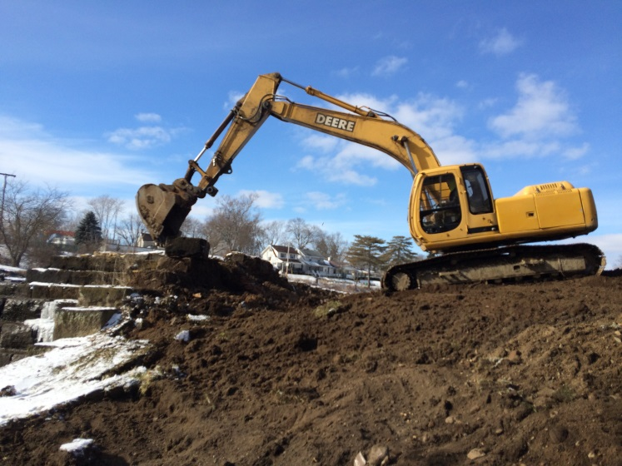 | 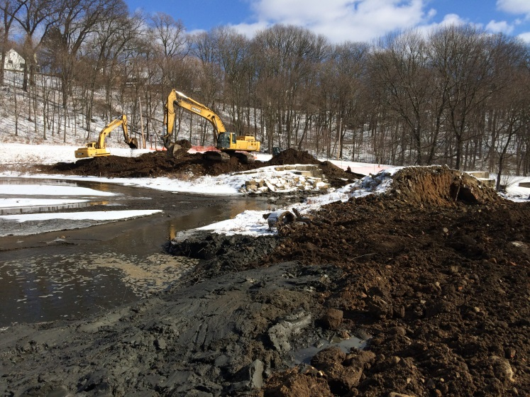
Location: Standing on east endwall looking west  Description: Sandstone blocks being removed from east endwall with 200LC excavator. | Location: Standing near northeast corner of building looking at spillway  Description: Lake drain inlet located underwater where foam is collecting. Dark gray material dredged to expose lake drain on water’s edge.

Photography Log
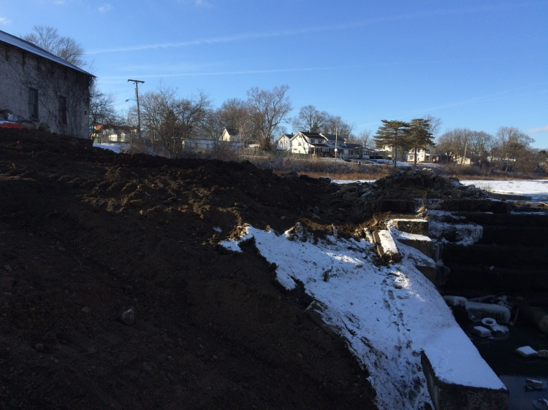 | 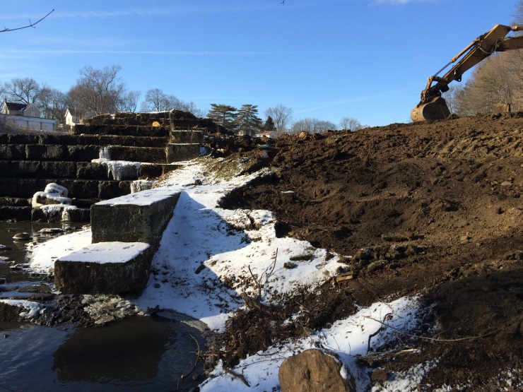
Location: Standing on gazebo, looking upstream  Description: West side of dam at end of day. | Location: Below the spillway on the east side of the creek, looking upstream  Description: East side of dam at end of day.
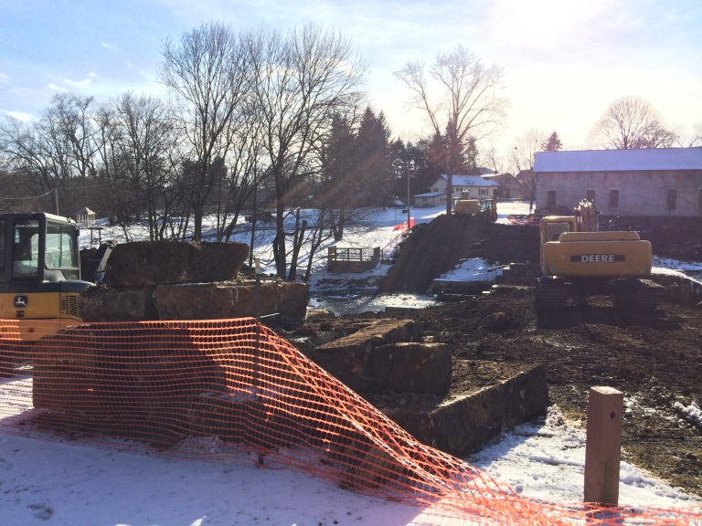 | 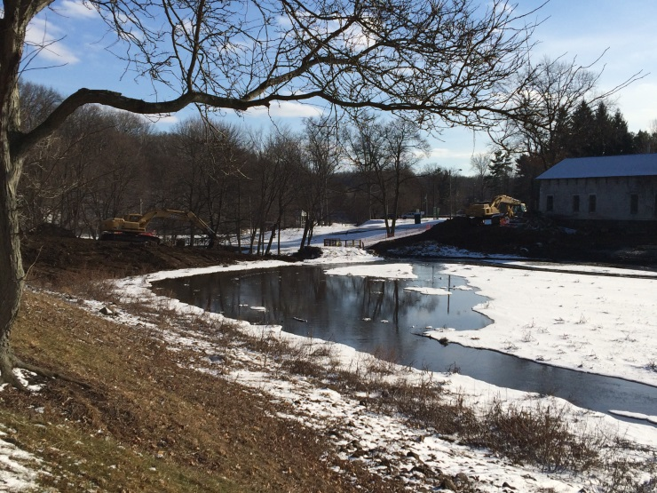
Location: Standing near exercise equipment, looking west  Description: Stockpiled sandstone blocks on east side of dam. | Location: Standing near telephone pole along walking path, looking at dam  Description: Dam at end of day.

