Client Name: City of Massillon |  |  |  | Project: Sippo Creek Reservoir Dam Lowering |  | Project Phase: N/A
Job No. : 60439145 |  |  |  |  |  |  |  | Consecutive Report No.: 004
Summary of Construction/Operation Activities (Include Additional Sheets as Necessary):
The top course of the spillway along with any other blocks above that course were removed to achieve the final grade of the spillway. The sandstone riprap lining the channel leading into the spillway was removed and stockpiled on both sides of the dam. An earthen cofferdam was built upstream of the spillway to force all water through the lake drain. The clay in the spillway approach was excavated 2’ below final grades for riprap placement. Dredged material from the lake drain inlet was placed near the northeast corner of the building.

Summary of Daily Observations (Include any Problems and Resolutions):
The large bucket from the 450C LC excavator was brought back to the site in the morning. The mini excavator was removed from the site at the end of the day.

After excavating upstream of the proposed spillway for riprap placement, it was discovered that the blocks making up the endwall upstream of the spillway consist of 2 courses of sandstone blocks bearing on clay. Multiple options have been suggested, including rebuilding the walls with three courses with one below grade.

Geotextile was delivered to the site, but upon inspection it did not meet the requirements of a 10 oz/sy nonwoven geotextile. The contractor was informed and agreed to have the correct geotextile delivered the following workday.

A 10’-4” length of 9” drainage pipe was delivered to the site today.

Stormwater Management, Erosion & Sediment Controls Observations (Include Sketches and Additional Sheet as Necessary):
none
Summary of Incidents, Accidents, or Health and Safety Issues:
none

Directives Given / Approvals Provided: |  |  |  |  | Material Description |  | Today’s Quantity: |  | Cumulative Quantity:
Reuse existing riprap
Surveyor’s Activities: |  |  |  |  | Visitors: |  | Construction Materials/Items Installed:
 |  |  |  |  | Jason Popiel – City of Massillon
 |  |  |  |  | Greg McCue – City of Massillon
 |  |  |  |  | Steve Pedro – City of Massillon
Weather: | AM: Snow |  | PM: Cloudy |  | Contractor Started Work: 8:30a |  | Field Representative Started Work: 7:45a
Temperature: | AM: 22 °F |  | PM: 26 °F |  | Contractor Stopped Work: 3:45p |  | Field Representative Stopped Work: 4:00p
Field Representative: Shane Lyons |  |  |  |  |   Field Representative’s Signature:  |  | Date: 2/6/2018
Reviewed by: Stephen Walker, P.E. |  |  |  |  | Reviewer’s Signature: |  | Date: Click here to enter a date.

Photography Log
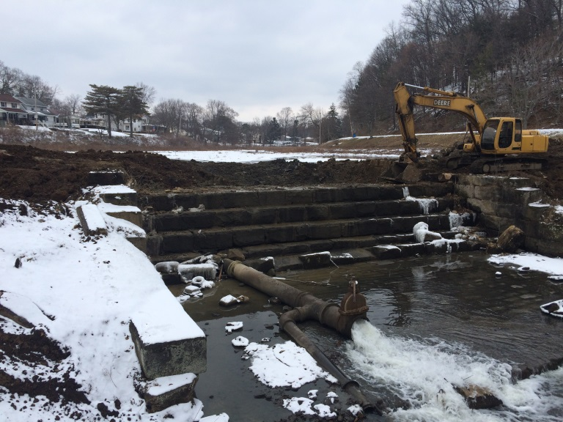 | 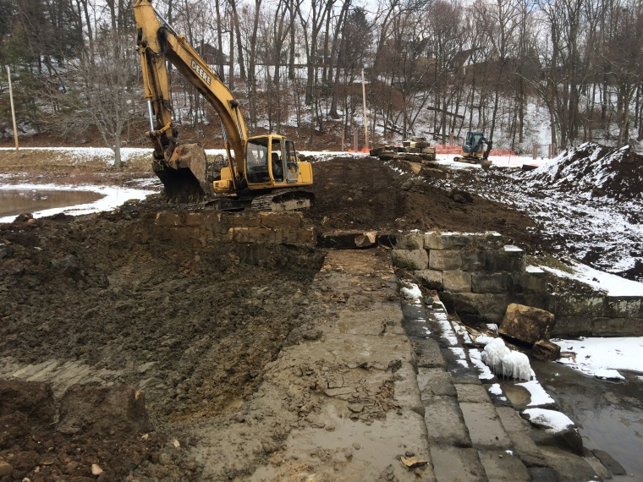
Location: Standing on gazebo looking at dam spillway  Description: Final course removed from spillway achieving final spillway grade. Lake drain pipe containing all flow from Sippo Creek. | Location: Standing on west endwall looking east  Description: Spillway at final grade. Clay in spillway approach excavated 2 feet for riprap installation.
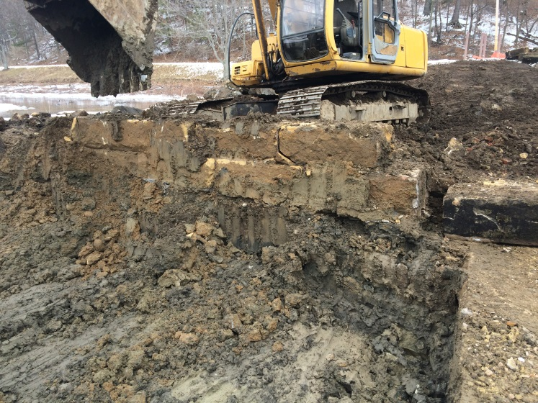 | 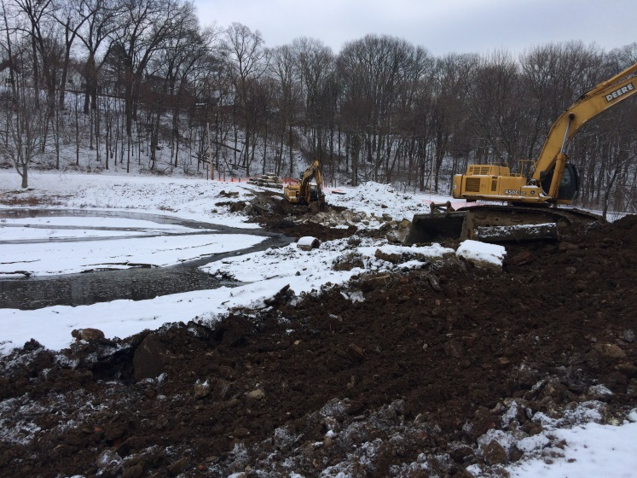
Location: Standing on spillway looking east  Description: Sandstone blocks upstream of spillway are only 2 courses deep, sitting on clay. Bottom of lower course is at proposed top of spillway approach grade.. | Location: Standing near northeast corner of building looking at spillway  Description: Lake drain inlet located underwater where foam is collecting. Earthen cofferdam built across spillway.

Photography Log
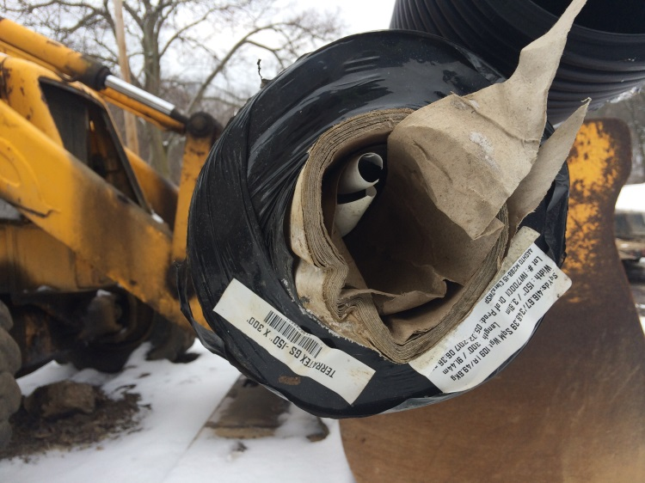 | 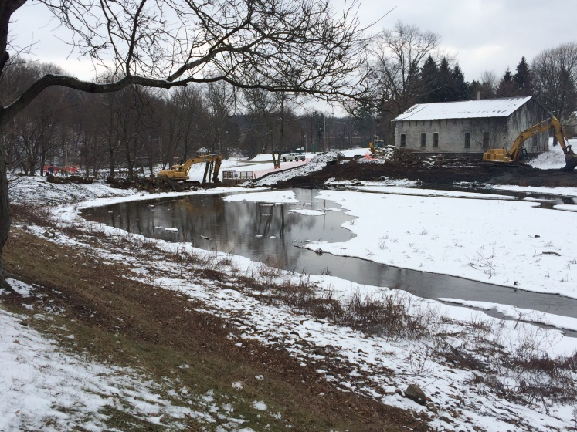
Location: N/A  Description: 12-foot roll of 4.2 oz/sy woven geotextile delivered to site, not acceptable for use. | Location: Standing near telephone pole along walking path, looking at dam  Description: Earthen cofferdam built upstream of spillway.
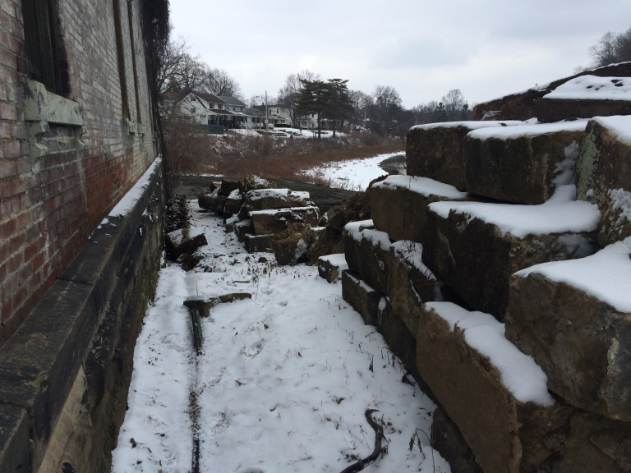 | 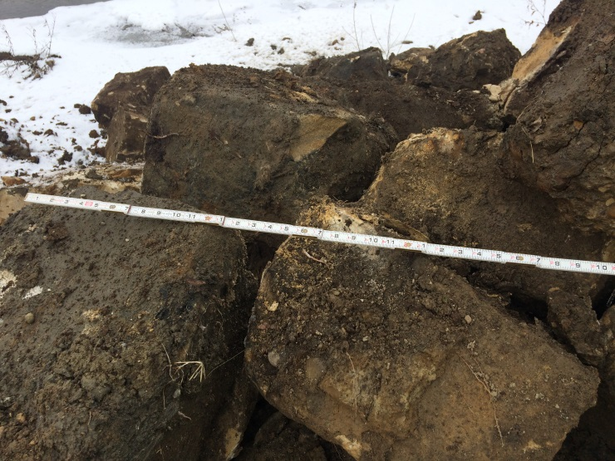
Location: Standing near southeast corner of building, looking north  Description: Stockpiled sandstone blocks on west side of dam. | Location: East of spillway  Description: Stockpiled sandstone riprap.

