Client Name: City of Massillon |  |  |  | Project: Sippo Creek Reservoir Dam Lowering |  | Project Phase: N/A
Job No. : 60439145 |  |  |  |  |  |  |  | Consecutive Report No.: 005
Summary of Construction/Operation Activities (Include Additional Sheets as Necessary):
A small amount of water ponded overnight in the excavation in the approach channel from yesterday so a generator and pump were used to remove the water. The excavation in this area was completed today. This included removing the 2 courses of sandstone blocks from each endwall and excavating those areas to the same depth as the subgrade of the approach channel. A layer of 11 oz/sy nonwoven geotextile was placed on the subgrade, and the sandstone riprap that was previously removed from the approach was placed on the geotextile.

Summary of Daily Observations (Include any Problems and Resolutions):
The unacceptable geotextile that was delivered yesterday was taken off site. A new supplier was identified who had 11 oz/sy nonwoven geotextile in stock and the Contractor brought it to the site.

Heavy snow in the morning resulted in a late start and slowed down construction activities today.

To address what would become a lack of embedment of the sandstone blocks in the endwall upstream of the spillway for final conditions due to unexpected conditions encountered yesterday, the contractor proposed the following plan: remove the blocks, excavate to the same subgrade as in the approach channel, extend the riprap under the endwalls, and grout the riprap under the endwall full prior to replacing the blocks. This plan is acceptable to AECOM. This will likely be extra work in a change order since it was not anticipated in the plan set.

Due to the snowstorm, the water level of the creek continued to rise throughout the day as the lake drain couldn’t handle the additional flow. The water in the reservoir began overflowing the earthen cofferdam into the work area while riprap was being placed. The geotextile had already been fixed in place prior to any substantial flow developing. All recycled riprap onsite was placed on the geotextile. The contractor created a larger breach in the cofferdam after the riprap was placed to relieve pressure from the cofferdam by letting the water flow over the spillway in addition to the lake drain.

Stormwater Management, Erosion & Sediment Controls Observations (Include Sketches and Additional Sheet as Necessary):
none
Summary of Incidents, Accidents, or Health and Safety Issues:
none

Directives Given / Approvals Provided: |  |  |  |  | Material Description |  | Today’s Quantity: |  | Cumulative Quantity:
 |  |  |  |  | 11 oz/sy nonwoven geotextile |  | 500 sy |  | 500 sy
Surveyor’s Activities: |  |  |  |  | Visitors: |  | Construction Materials/Items Installed:
 |  |  |  |  | Jason Popiel – City of Massillon |  | 11 oz/sy nonwoven geotextile
 |  |  |  |  | Greg McCue – City of Massillon |  | Recycled sandstone riprap
 |  |  |  |  | Steve Pedro – City of Massillon
Weather: | AM: Heavy Snow |  | PM: Cloudy |  | Contractor Started Work: -- |  | Field Representative Started Work: 9:00a
Temperature: | AM: 23 °F |  | PM: 22 °F |  | Contractor Stopped Work: 4:00p |  | Field Representative Stopped Work: 4:45p
Field Representative: Shane Lyons |  |  |  |  | 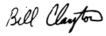  Field Representative’s Signature: 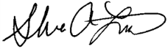 |  | Date: 2/7/2018
Reviewed by: Stephen Walker, P.E. |  |  |  |  | Reviewer’s Signature: |  | Date: Click here to enter a date.

Photography Log
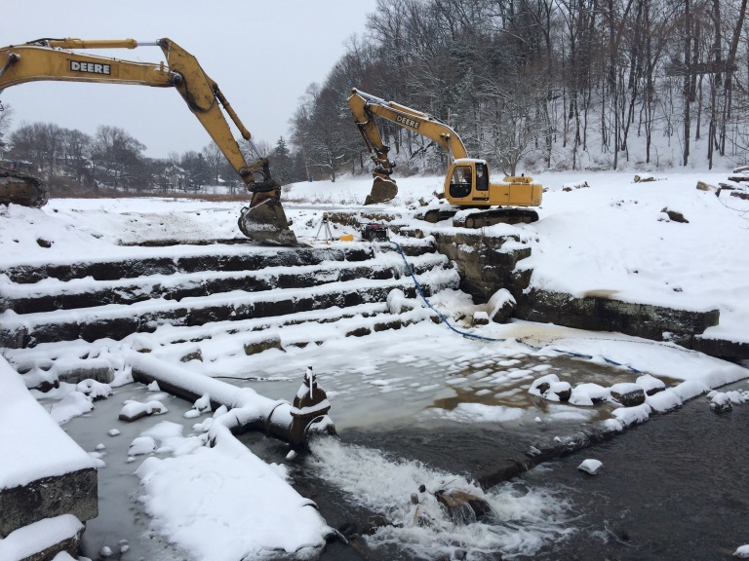 | 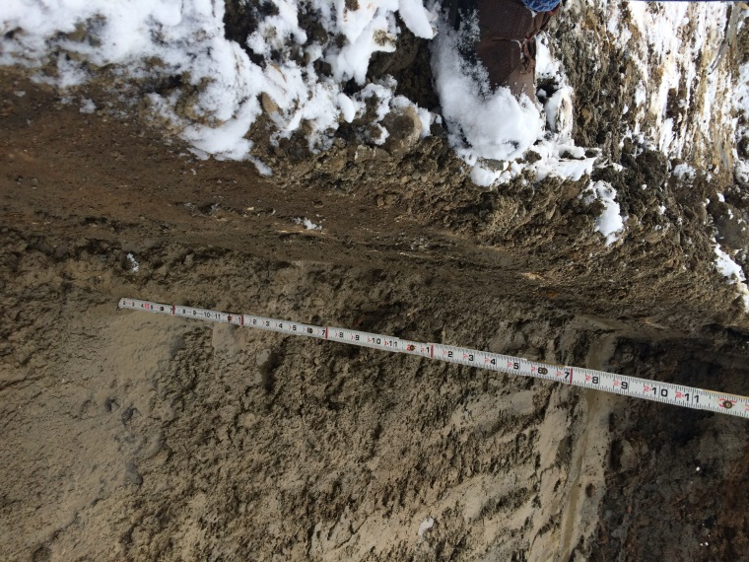
Location: Standing on gazebo looking at dam spillway  Description: Generator and pump removing water from the excavation in the approach to the spillway. | Location: Standing on spillway  Description: Excavation for riprap in spillway approach 2 feet deep to subgrade.
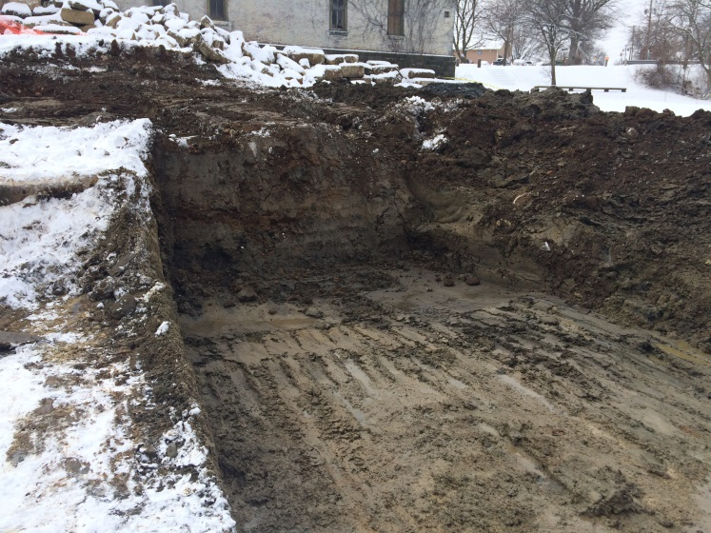 | 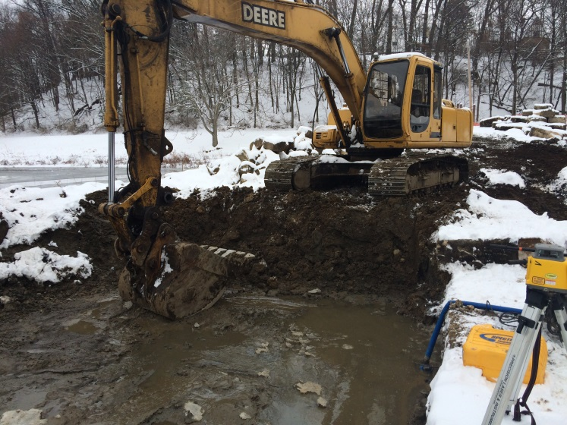
Location: Standing on spillway looking west  Description: Sandstone blocks upstream of spillway removed and soil excavated to same depth as spillway approach. Grouted riprap to extend under endwall, which will then be rebuilt. | Location: Standing on spillway looking east  Description: Sandstone blocks upstream of spillway removed and soil excavated to same depth as spillway approach. Grouted riprap to extend under endwall, which will then be rebuilt.

Photography Log
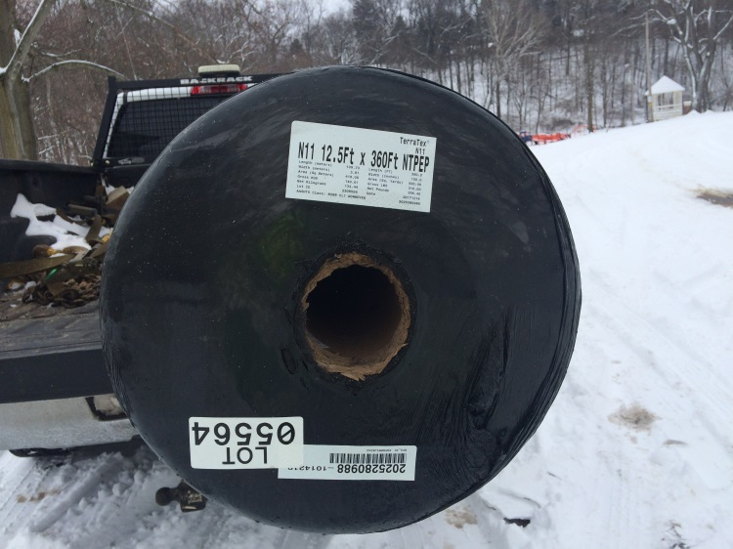 | 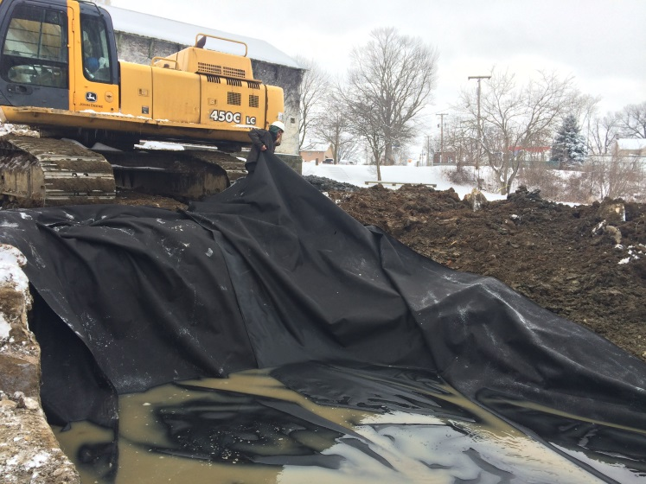
Location: N/A  Description: 12.5-foot roll of 11 oz/sy nonwoven geotextile brought to sie for placement under riprap. | Location: Standing on spillway looking northwest  Description: Geotextile being placed in excavation.
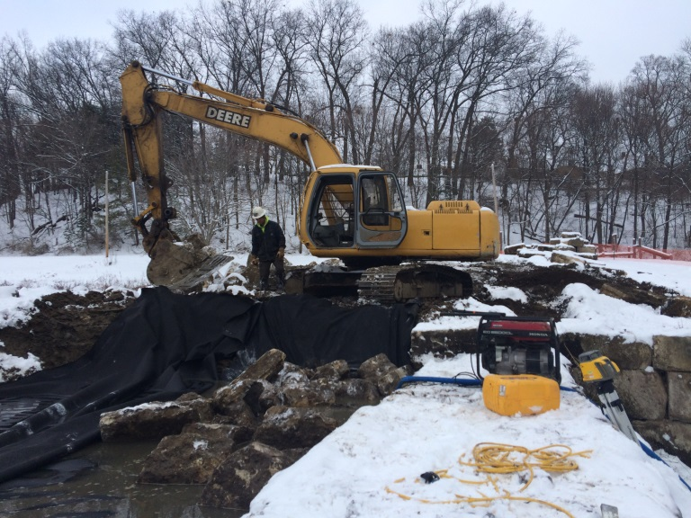 | 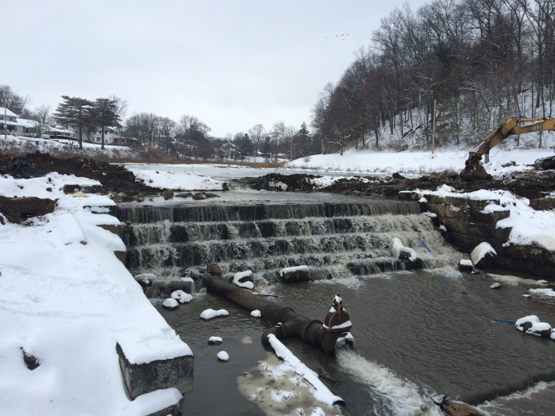
Location: Standing on spillway looking east  Description: Recycled sandstone riprap being placed on geotextile. | Location: Standing on gazebo looking at dam spillway  Description: Water flowing over spillway and through lake drain after riprap placement.

Photography Log
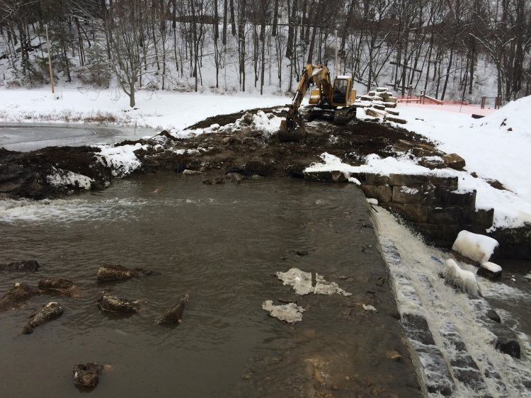 | 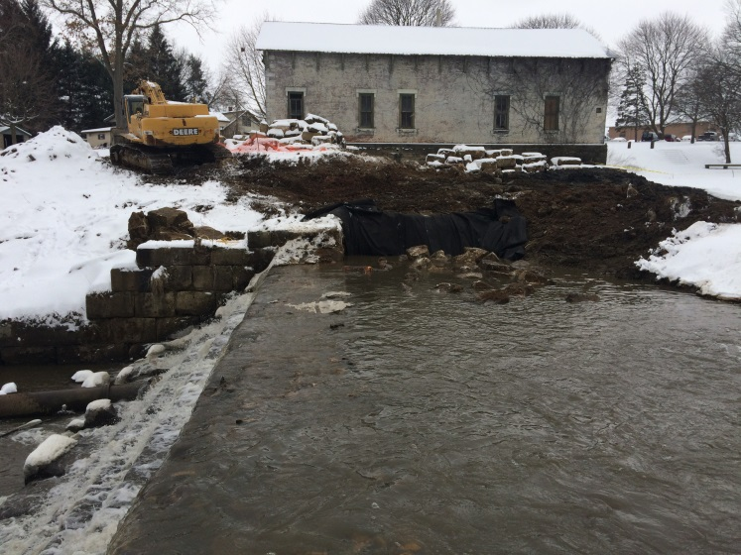
Location: Standing on west endwall looking east  Description: Water flowing over spillway after geotextile and riprap placement in spillway approach. Riprap visible in areas where more was placed. | Location: Standing on east endwall looking west  Description: Water flowing over spillway after geotextile and riprap placement in spillway approach. Riprap visible in areas where more was placed.
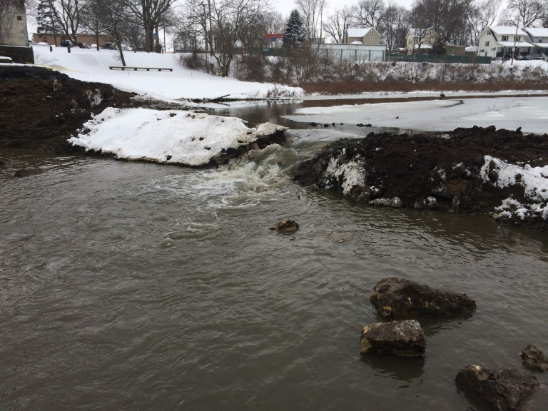 | 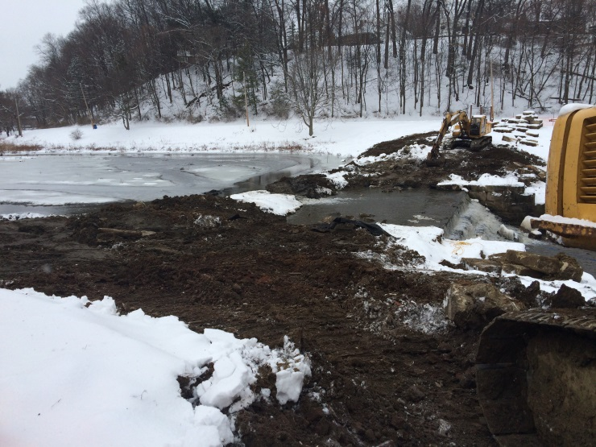
Location: Standing on spillway looking upstream  Description: Breach in earthen cofferdam at end of day to relieve pressure on cofferdam. | Location: Standing near southeast corner of building  Description: View across dam including earthen cofferdam and spillway approach.

