Client Name: City of Massillon |  |  |  | Project: Sippo Creek Reservoir Dam Lowering |  | Project Phase: N/A
Job No. : 60439145 |  |  |  |  |  |  |  | Consecutive Report No.: 006
Summary of Construction/Operation Activities (Include Additional Sheets as Necessary):
Type A riprap was delivered to the site. The excavator moved the riprap from the staging area where it was delivered to the slope on the west side of the creek near the gazebo. The Contractor brought in a 10-inch pump and placed it on the west side of the dam to divert the water, but it was unable to handle all of the flow from Sippo Creek. A 6-inch pump was brought in tandem with the other pump, but they were still unable to keep the water in the reservoir from rising. The Contractor dredged sediment around the lake drain inlet to get it flowing again, and was able to clear the lake drain at the end of the day. The water level in the reservoir dropped when the lake drain began flowing.

The Surveyor arrived onsite in the afternoon to place grade stakes and mark limits of riprap.

Summary of Daily Observations (Include any Problems and Resolutions):
The Contractor had the Type B riprap and some of the Type A riprap delivered to the site on Friday. The Contractor stacked the Type B riprap in the spillway approach on Friday.

The lake drain was clogged in the morning and had virtually no flow through it, therefore all flow was going over the spillway.

Stormwater Management, Erosion & Sediment Controls Observations (Include Sketches and Additional Sheet as Necessary):
none
Summary of Incidents, Accidents, or Health and Safety Issues:
none

Directives Given / Approvals Provided: |  |  |  |  | Material Description |  | Today’s Quantity: |  | Cumulative Quantity:
 |  |  |  |  | 11 oz/sy nonwoven geotextile |  | 0 sy |  | 500 sy
 |  |  |  |  | Type A riprap |  | 59.81 tons |  | 95.48 tons
 |  |  |  |  | Type B riprap |  | 0 tons |  | 112.48 tons
Surveyor’s Activities: |  |  |  |  | Visitors: |  | Construction Materials/Items Installed:
Mark limits of riprap |  |  |  |  | Jason Popiel – City of Massillon
Place grade stakes |  |  |  |  | Steve Pedro – City of Massillon
 |  |  |  |  | Steve Walker – AECOM
 |  |  |  |  | Josh Garland – ODNR
Weather: | AM: Sunny |  | PM: Sunny |  | Contractor Started Work: 7:45a |  | Field Representative Started Work: 8:20a
Temperature: | AM: 25 °F |  | PM: 33 °F |  | Contractor Stopped Work: 5:15p |  | Field Representative Stopped Work: 5:15p
Field Representative: Shane Lyons |  |  |  |  |   Field Representative’s Signature:  |  | Date: 2/12/2018
Reviewed by: Stephen Walker, P.E. |  |  |  |  | Reviewer’s Signature: |  | Date: Click here to enter a date.

Photography Log
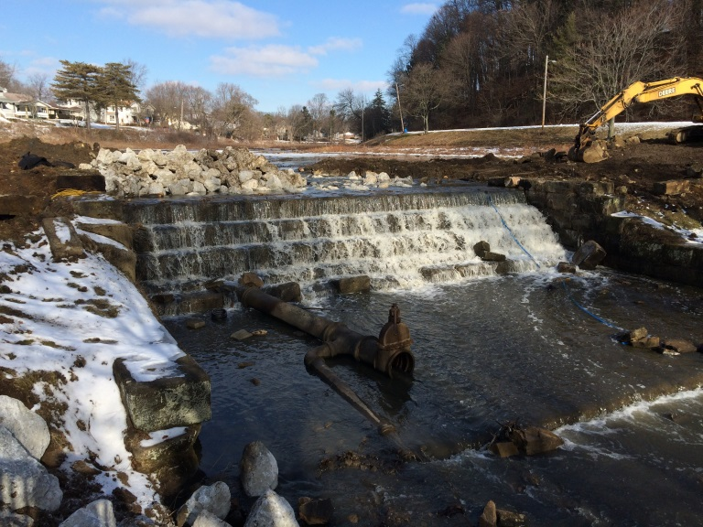 | 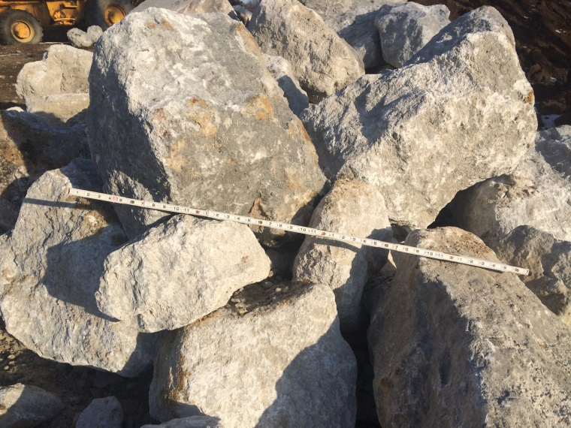
Location: Standing on gazebo looking at dam spillway  Description: Type A riprap was stacked on the spillway approach Friday. The lake drain is clogged and not flowing. | Location: Staging area near building  Description: Type A riprap delivered to site.
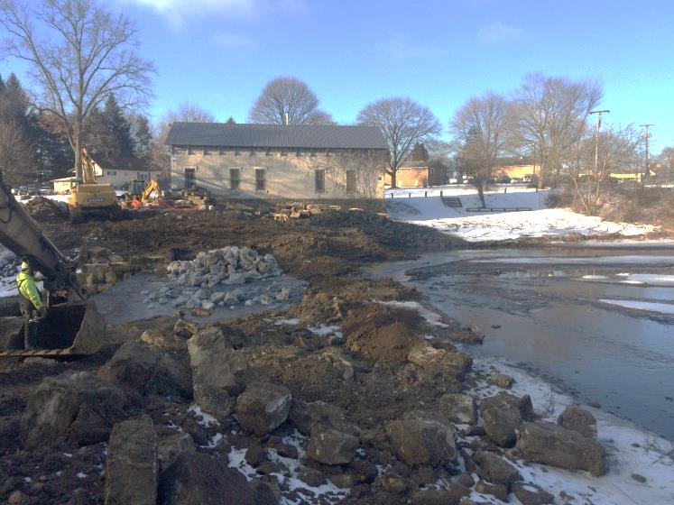 | 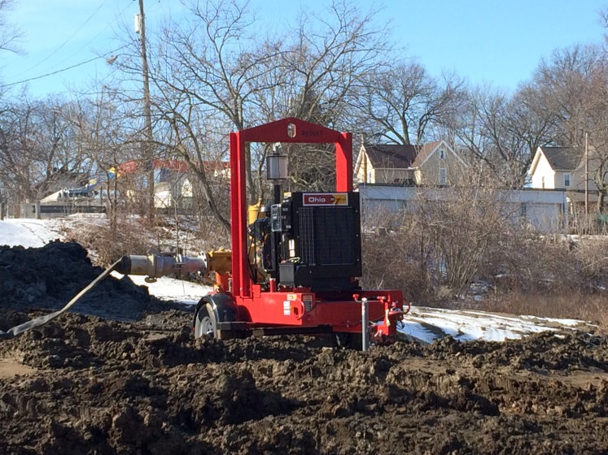
Location: Standing on east end of dam looking west  Description: Water level in reservoir reduced since last week. Type B riprap from Friday visible in spillway approach. | Location: Edge of water near lake drain inlet  Description: 10-inch pump before 6-inch pump was brought to the site.

Photography Log
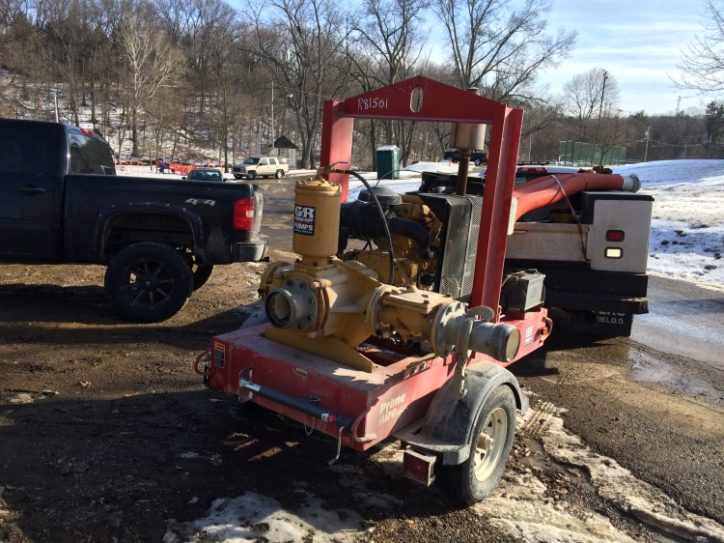 | 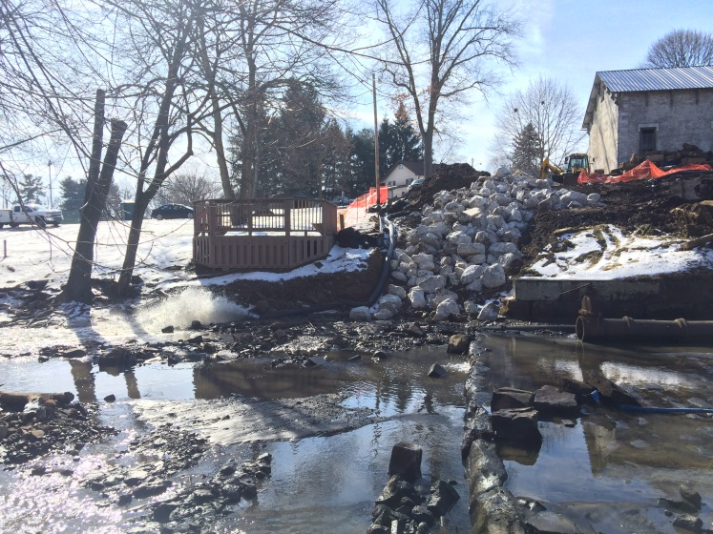
Location: Staging area near building  Description: 6-inch pump being delivered to the site. | Location: Standing at south end of east endwall looking west  Description: Type A riprap stockpiled on slope. Pump hose running between riprap and gazebo and expelling water in front of gazebo.
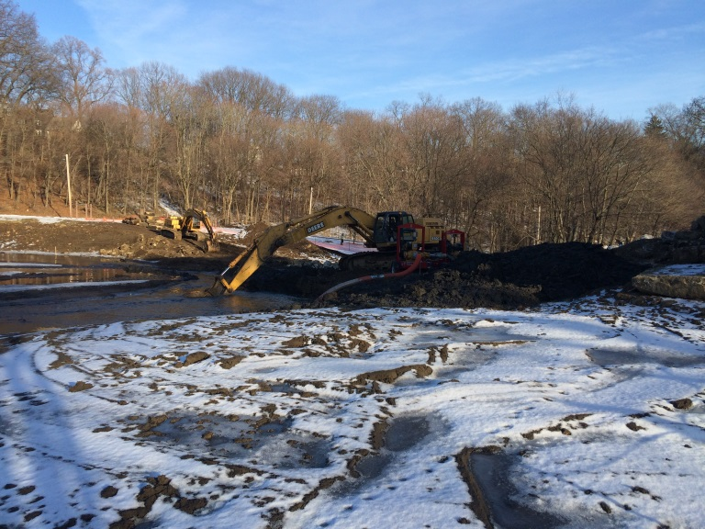 | 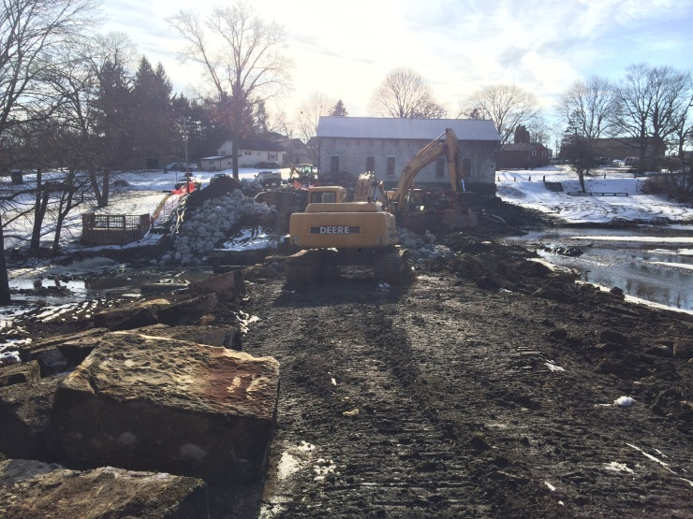
Location: Standing at northwest corner of building looking at dam  Description: Pumps pulling water from reservoir near lake drain inlet. | Location: Standing east of dam looking west  Description: Pumps pulling water from reservoir with hoses running near gazebo.

