Client Name: City of Massillon |  |  |  | Project: Sippo Creek Reservoir Dam Lowering |  | Project Phase: N/A
Job No. : 60439145 |  |  |  |  |  |  |  | Consecutive Report No.: 007
Summary of Construction/Operation Activities (Include Additional Sheets as Necessary):
none
Summary of Daily Observations (Include any Problems and Resolutions):
The Contractor inadvertently forgot to open the release valves in the pumps yesterday before leaving the site. The water in the pumps froze and therefore the work area was unable to be pumped free of water. The Contractor planned to head back to their shop to get supplies for thawing out the pumps.

Stormwater Management, Erosion & Sediment Controls Observations (Include Sketches and Additional Sheet as Necessary):
none
Summary of Incidents, Accidents, or Health and Safety Issues:
none

Directives Given / Approvals Provided: |  |  |  |  | Material Description |  | Today’s Quantity: |  | Cumulative Quantity:
 |  |  |  |  | 11 oz/sy nonwoven geotextile |  | 0 sy |  | 500 sy
 |  |  |  |  | Type A riprap |  | 0 tons |  | 102.85 tons
 |  |  |  |  | Type B riprap |  | 0 tons |  | 112.48 tons
Surveyor’s Activities: |  |  |  |  | Visitors: |  | Construction Materials/Items Installed:
Weather: | AM: Sunny |  | PM: -- |  | Contractor Started Work: ~8:00a |  | Field Representative Started Work: 8:30a
Temperature: | AM: 18 °F |  | PM: -- °F |  | Contractor Stopped Work: -- |  | Field Representative Stopped Work: 10:10a
Field Representative: Shane Lyons |  |  |  |  |   Field Representative’s Signature:  |  | Date: 2/21/2018
Reviewed by: Stephen Walker, P.E. |  |  |  |  | Reviewer’s Signature: |  | Date: Click here to enter a date.

Photography Log
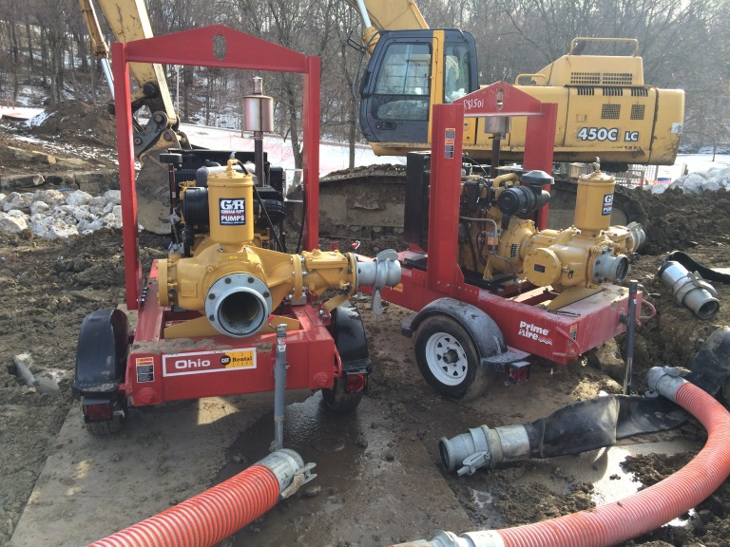 | 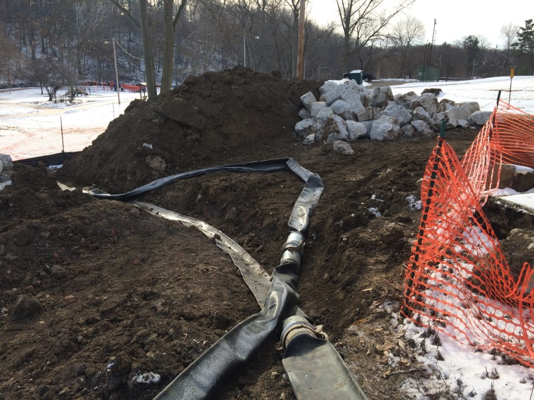
Location: Edge of water near southwest corner of reservoir  Description: Both pumps that were brought to the site froze overnight. | Location: Standing near stockpile of sandstone blocks, looking south  Description: Pump hoses laying in/near trench between dam and construction entrance.
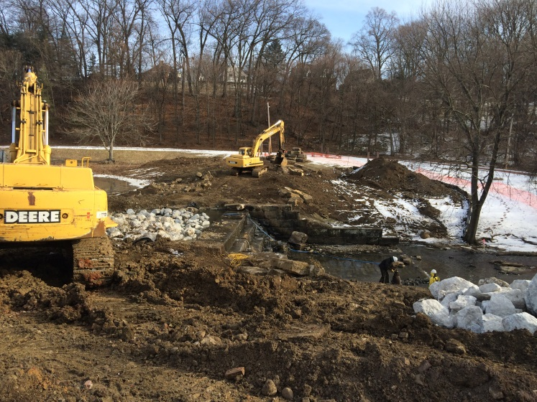 | 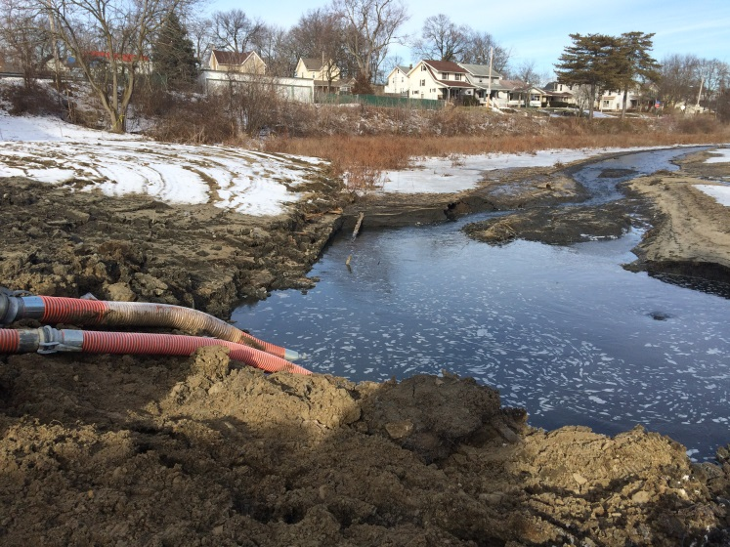
Location: Standing near stockpile of sandstone blocks, looking east  Description: All flow from Sippo Creek going through lake drain. | Location: Edge of water near lake drain inlet  Description: Intake pipes to pump placed in pool of water near lake drain inlet. Small whirlpool visible above lake drain inlet.

