Client Name: City of Massillon |  |  |  | Project: Sippo Creek Reservoir Dam Lowering |  | Project Phase: N/A
Job No. : 60439145 |  |  |  |  |  |  |  | Consecutive Report No.: 008
Summary of Construction/Operation Activities (Include Additional Sheets as Necessary):
none
Summary of Daily Observations (Include any Problems and Resolutions):
The Contractor was at their shop fabricating a cap for the pipe that branches off of the lake drain while AECOM was onsite today. It was noted that the lake drain had been rotated clockwise so that the pipe was sticking up in the air rather than laying flat on the stilling basin. The Contractor planned to arrive at the site at 1:00pm.

Stormwater Management, Erosion & Sediment Controls Observations (Include Sketches and Additional Sheet as Necessary):
none
Summary of Incidents, Accidents, or Health and Safety Issues:
none

Directives Given / Approvals Provided: |  |  |  |  | Material Description |  | Today’s Quantity: |  | Cumulative Quantity:
 |  |  |  |  | 11 oz/sy nonwoven geotextile |  | 0 sy |  | 500 sy
 |  |  |  |  | Type A riprap |  | 0 tons |  | 102.85 tons
 |  |  |  |  | Type B riprap |  | 0 tons |  | 112.48 tons
Surveyor’s Activities: |  |  |  |  | Visitors: |  | Construction Materials/Items Installed:
Weather: | AM: Cloudy |  | PM: -- |  | Contractor Started Work: -- |  | Field Representative Started Work: 8:30a
Temperature: | AM: 38 °F |  | PM: -- °F |  | Contractor Stopped Work: -- |  | Field Representative Stopped Work: 9:10a
Field Representative: Shane Lyons |  |  |  |  | 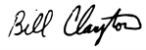  Field Representative’s Signature: 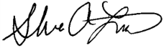 |  | Date: 2/21/2018
Reviewed by: Stephen Walker, P.E. |  |  |  |  | Reviewer’s Signature: |  | Date: Click here to enter a date.

Photography Log
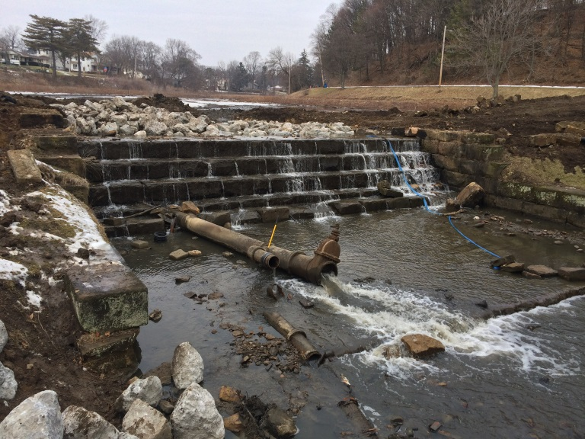 | 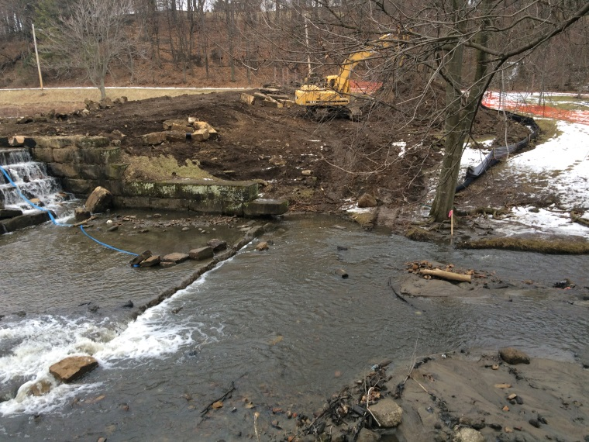
Location: Standing on gazebo looking at spillway  Description: Most flow going through lake drain. Lake drain twisted clockwise to work on pipe that branches off before gate valve. | Location: Standing on gazebo looking east  Description: Surveyors stake near tree marking edge of proposed riprap.
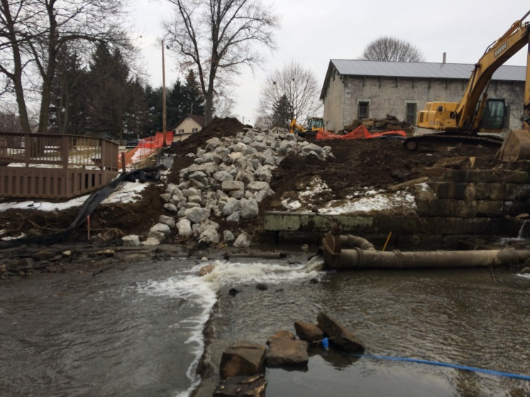 | 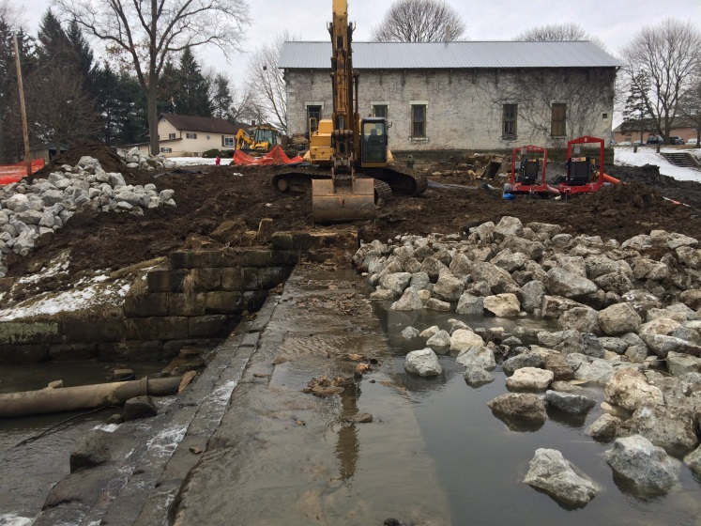
Location: Standing at south end of east endwall looking west  Description: Surveyors stake near gazebo marking edge of proposed riprap. | Location: Standing on east endwall at spillway looking west  Description: Small amount of water flowing over spillway.

