Client Name: City of Massillon |  |  |  | Project: Sippo Creek Reservoir Dam Lowering |  | Project Phase: N/A
Job No. : 60439145 |  |  |  |  |  |  |  | Consecutive Report No.: 009
Summary of Construction/Operation Activities (Include Additional Sheets as Necessary):
The Contractor excavated the area downstream of the spillway as well as the slope on the east side of the creek for placement of riprap. Two 2-inch pumps were used to dewater the excavation prior to geotextile and riprap placement. Geotextile and riprap were placed in the excavation in the creek bed and on the slope east of the creek. Soil was moved around the site and was used to regrade the area at the southeast corner of the reservoir to make the slope accessible to a lawn mower.

Summary of Daily Observations (Include any Problems and Resolutions):
The pipe that branches off of the lake drain had a cap placed over it to stop flow out of the pipe. The lake drain was extended beyond the excavation for riprap placement by inserting a corrugated plastic pipe into the drain. The riprap on the west side of the pipe extension had already been placed prior to AECOM’s arrival onsite.

Stormwater Management, Erosion & Sediment Controls Observations (Include Sketches and Additional Sheet as Necessary):
The pipe that branches off of the lake drain had a cap placed over it to stop flow out of the pipe. The lake drain was extended beyond the excavation for riprap placement by inserting a corrugated plastic pipe into the drain.

Summary of Incidents, Accidents, or Health and Safety Issues:
none

Directives Given / Approvals Provided: |  |  |  |  | Material Description |  | Today’s Quantity: |  | Cumulative Quantity:
 |  |  |  |  | 11 oz/sy nonwoven geotextile |  | 0 sy |  | 500 sy
 |  |  |  |  | Type A riprap |  | 0 tons |  | 102.85 tons
 |  |  |  |  | Type B riprap |  | 0 tons |  | 112.48 tons
Surveyor’s Activities: |  |  |  |  | Visitors: |  | Construction Materials/Items Installed:
 |  |  |  |  |  |  | 11 oz/sy nonwoven geotextile
 |  |  |  |  |  |  | Type A riprap
 |  |  |  |  |  |  | Type B riprap
Weather: | AM: Cloudy |  | PM: Rain |  | Contractor Started Work: -- |  | Field Representative Started Work: 11:45a
Temperature: | AM: 59 °F |  | PM: 61 °F |  | Contractor Stopped Work: -- |  | Field Representative Stopped Work: 5:00p
Field Representative: Shane Lyons |  |  |  |  |   Field Representative’s Signature:  |  | Date: 2/21/2018
Reviewed by: Stephen Walker, P.E. |  |  |  |  | Reviewer’s Signature: |  | Date: Click here to enter a date.

Photography Log
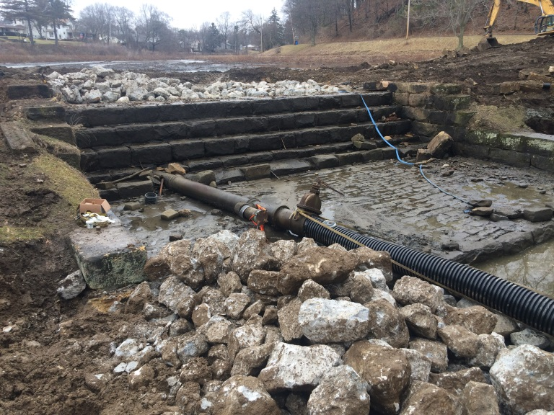 | 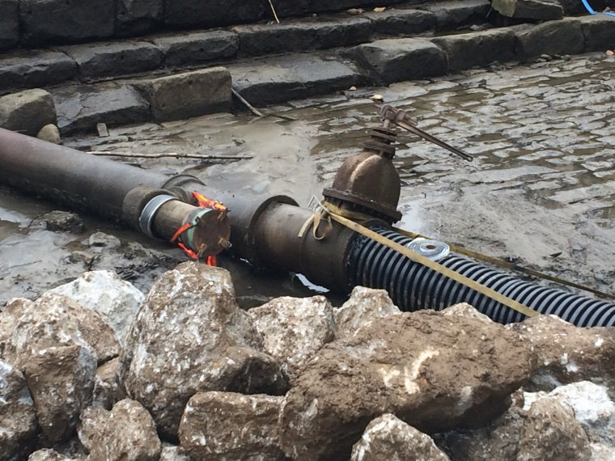
Location: Standing on gazebo looking at spillway  Description: Lake drain extended with corrugated plastic pipe to make flow bypass work area. | Location: Standing on gazebo looking at spillway  Description: Pipe branching off of lake drain with cap blocking flow.
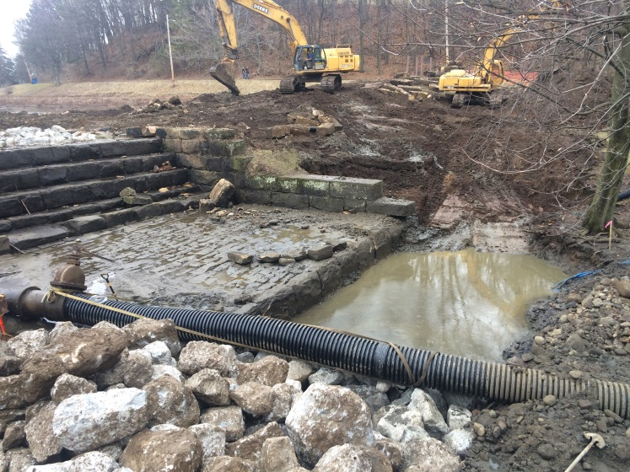 | 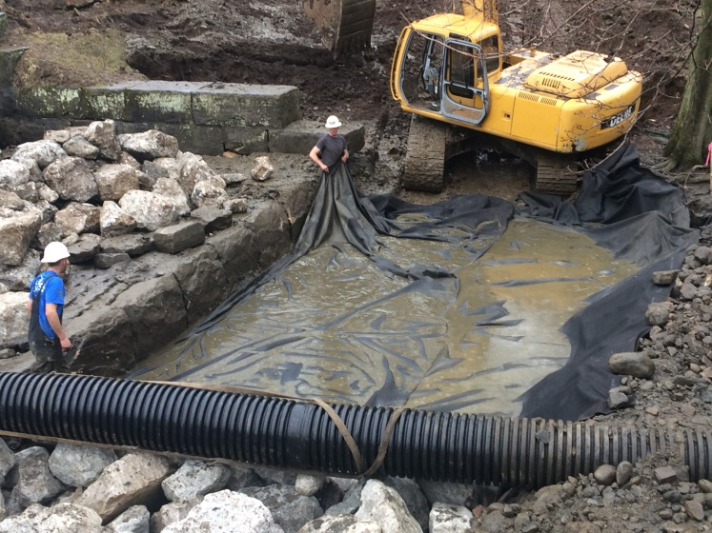
Location: Standing on gazebo looking east  Description: Riprap placed and stockpiled west of lake drain extension. Area east of lake drain extension excavated for riprap placement. | Location: Standing on gazebo looking east  Description: Geotextile placed in excavation.

Photography Log
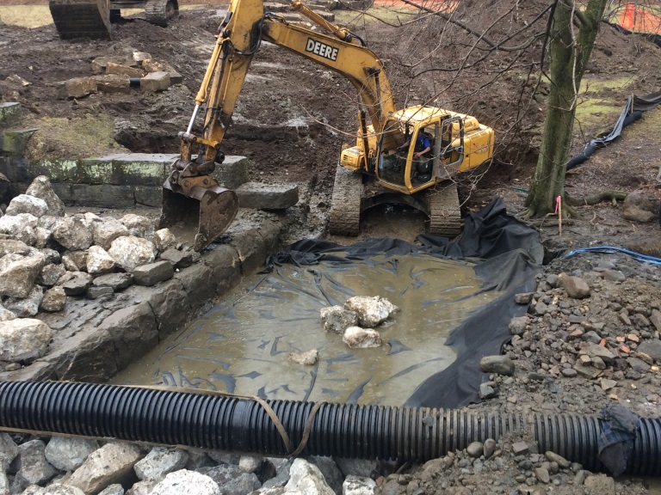 | 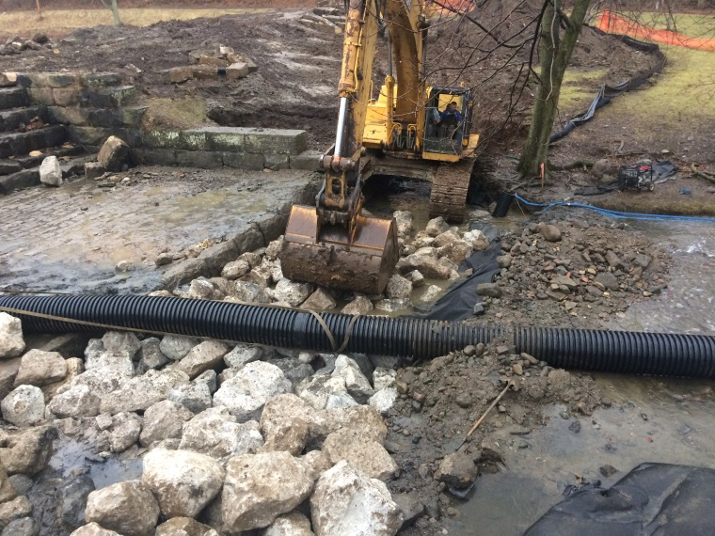
Location: Standing on gazebo looking east  Description: Riprap being placed on overlap of geotextile. | Location: Standing on gazebo looking east  Description: Geotextile covered in riprap.
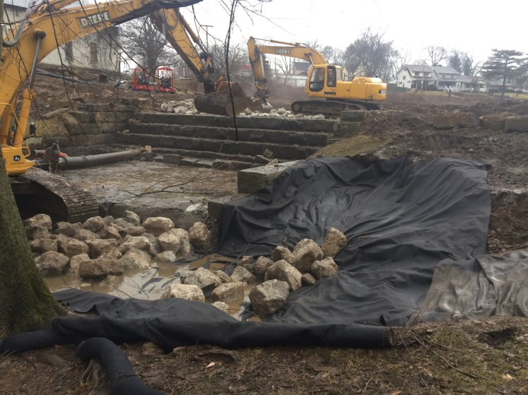 | 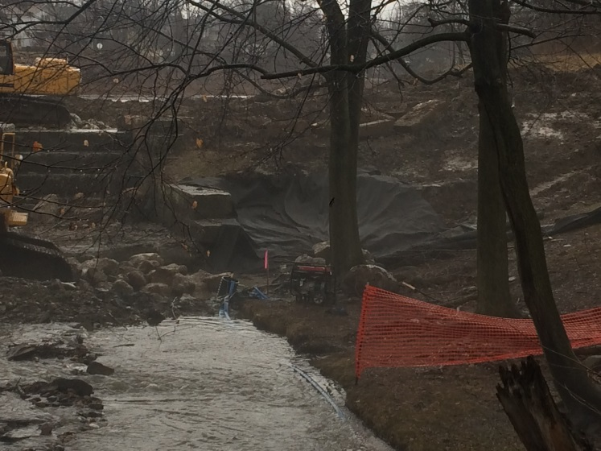
Location: Standing on east side of creek looking at spillway  Description: Geotextile and riprap being placed on east slope. | Location: Standing on pedestrian bridge looking upstream  Description: Geotextile and riprap being placed on east slope..

