Client Name: City of Massillon |  |  |  | Project: Sippo Creek Reservoir Dam Lowering |  | Project Phase: N/A
Job No. : 60439145 |  |  |  |  |  |  |  | Consecutive Report No.: 010
Summary of Construction/Operation Activities (Include Additional Sheets as Necessary):
The Contractor picked out riprap that was mixed with dirt on the east side of the dam and placed it in the approach channel over geotextile. Additional riprap taken from stockpile in staging area near construction entrance. The 2” pump was used to pull water from the reservoir to wash the riprap, after which the pump removed water from the area. The riprap in the approach channel was grouted in place with 20 cy of grout. The area under the east endwall was formed to hold the sandstone blocks, which will be placed on top of the grouted riprap later.

Summary of Daily Observations (Include any Problems and Resolutions):
Due to the weather conditions that delayed work for several weeks, the riprap that was previously placed on both the upstream and downstream sides of the dam had gotten silted in prior to grouting. The riprap on the approach channel was removed, new geotextile was placed, and the riprap was placed over the geotextile. The riprap was coated in dirt, and AECOM recommended hosing it off to clean it so the grout would stick. Some riprap downstream of the dam had also been removed. The first truck started with a slump of 3 inches. A total of 75 gallons of water was added to achieve a slump of 5, and a bag of calcium was also added. The second truck added 80 gallons of water and a bag of calcium.

Stormwater Management, Erosion & Sediment Controls Observations (Include Sketches and Additional Sheet as Necessary):
The lake drain was handling all flow in the creek. The water level in the reservoir was very low.

Summary of Incidents, Accidents, or Health and Safety Issues:
none

Directives Given / Approvals Provided: |  |  |  |  | Material Description |  | Today’s Quantity: |  | Cumulative Quantity:
 |  |  |  |  | 11 oz/sy nonwoven geotextile |  | 0 sy |  | 500 sy
 |  |  |  |  | Type A riprap |  | 0 tons |  | 102.85 tons
 |  |  |  |  | Type B riprap |  | 0 tons |  | 146.77 tons
 |  |  |  |  | Grout |  | 20 cy |  | 20 cy
Surveyor’s Activities: |  |  |  |  | Visitors: |  | Construction Materials/Items Installed:
Investigate stream bed realignment in reservoir |  |  |  |  | Greg McCue – City of Massillon |  | 11 oz/sy nonwoven geotextile
 |  |  |  |  | Surveyor – City of Massillon |  | Type B riprap
 |  |  |  |  |  |  | Grout
Weather: | AM: -- |  | PM: Snow |  | Contractor Started Work: -- |  | Field Representative Started Work: 12:00p
Temperature: | AM: -- °F |  | PM: 36 °F |  | Contractor Stopped Work: -- |  | Field Representative Stopped Work: 5:00p
Field Representative: Shane Lyons |  |  |  |  | 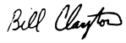  Field Representative’s Signature: 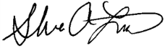 |  | Date: 3/20/2018
Reviewed by: Stephen Walker, P.E. |  |  |  |  | Reviewer’s Signature: |  | Date: Click here to enter a date.

Photography Log
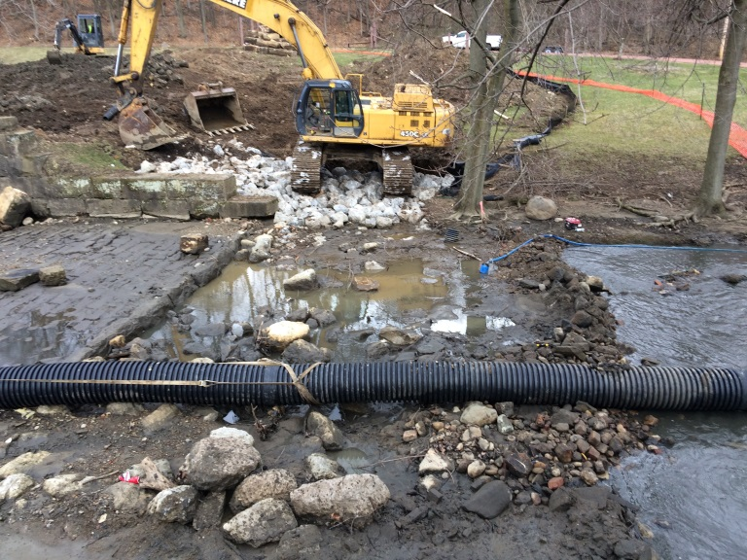 | 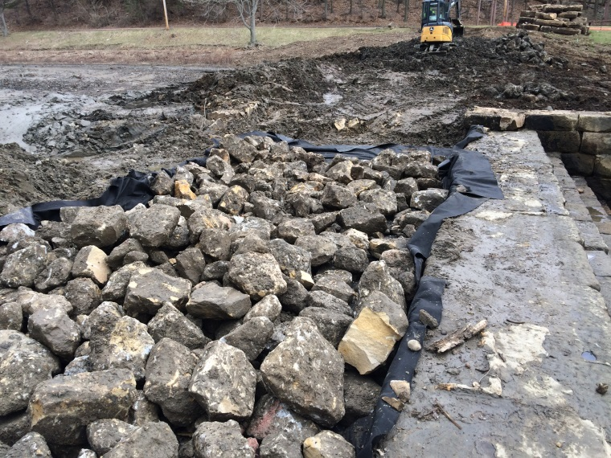
Location: Standing on gazebo looking across creek  Description: Riprap placed downstream filled in with silt. Some riprap removed. Lake drain extended with corrugated plastic pipe to make flow bypass work area. | Location: Standing on west endwall looking east  Description: Riprap placed over geotextile in approach channel, prior to washing.
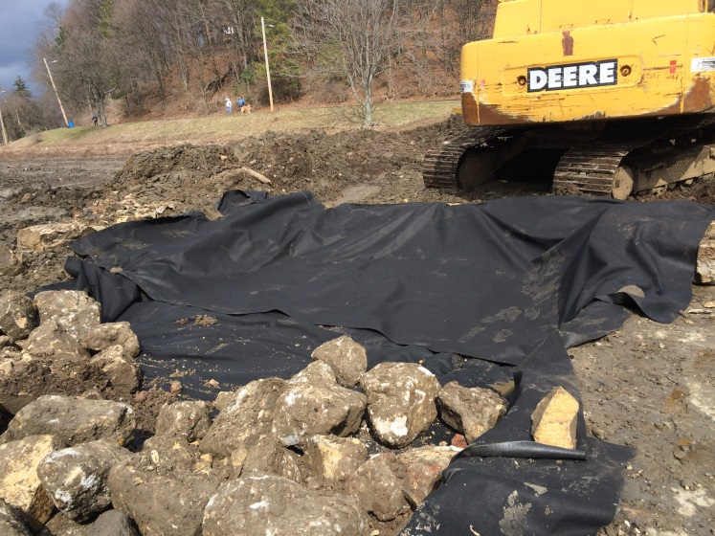 | 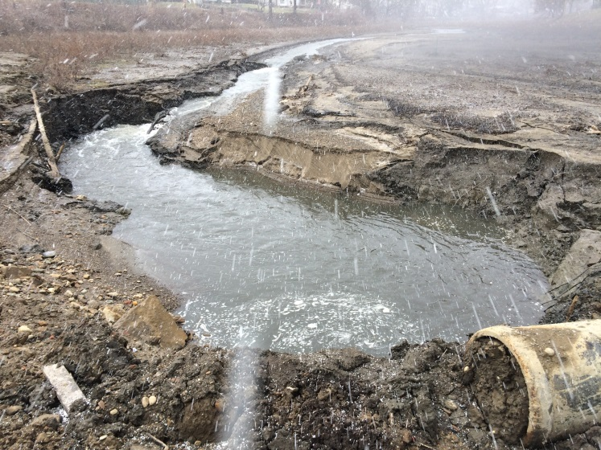
Location: Standing on spillway looking at east side of approach channel  Description: Geotextile placed prior to receiving additional riprap. | Location: West side of dam looking north  Description: Pool in reservoir near lake drain inlet.

Photography Log
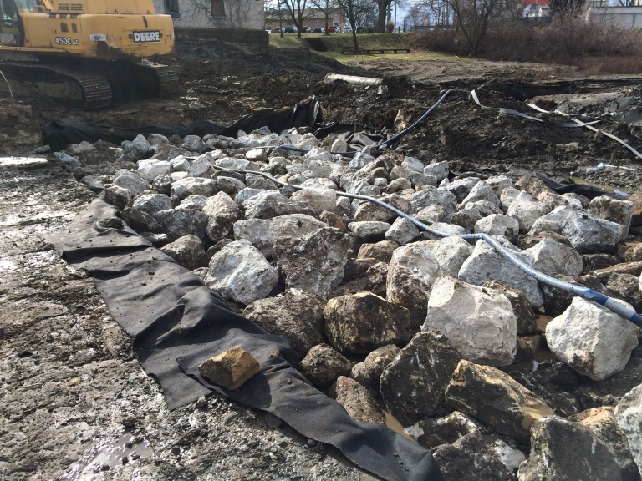 | 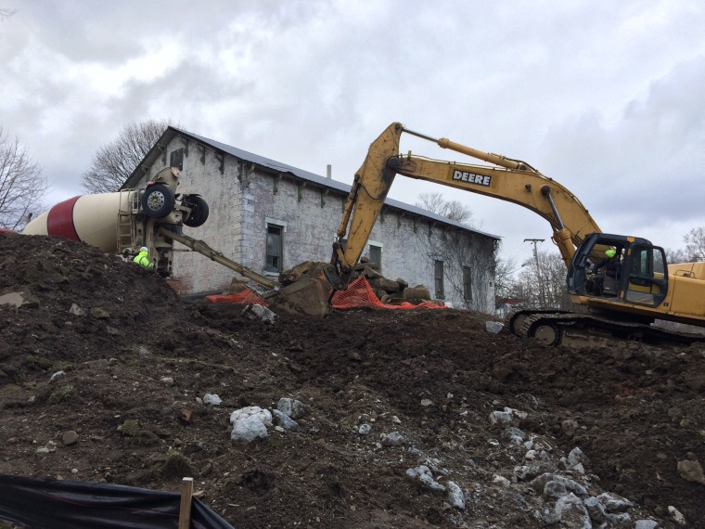
Location: Standing on spillway looking west  Description: Riprap in place, being washed prior to grouting. | Location: Standing on gazebo looking at existing building  Description: Concrete truck pouring grout into excavator bucket.
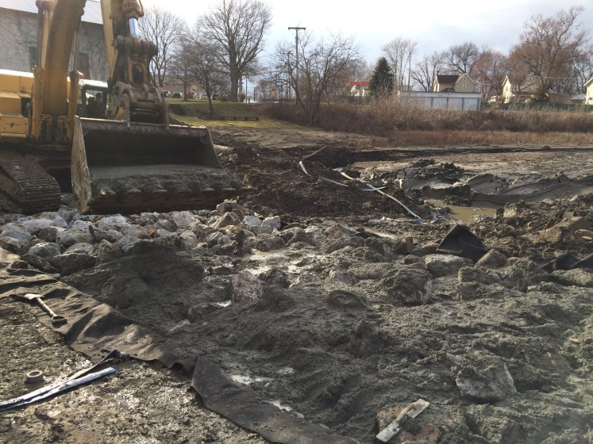 | 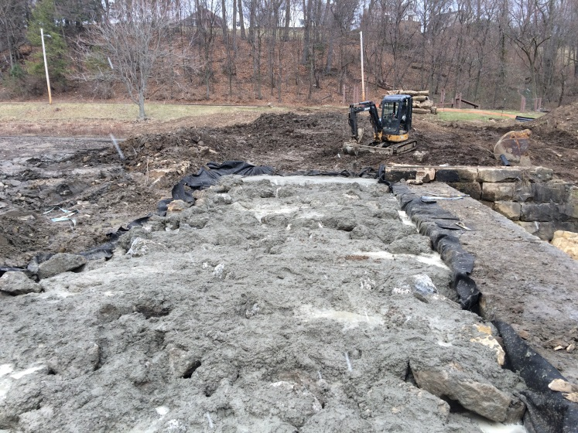
Location: Standing on spillway looking northwest  Description: Excavator bucket being used to place grout. | Location: Standing west of approach channel looking east  Description: Spillway approach grouted. Area under east endwall formed for block placement.

