Client Name: City of Massillon |  |  |  | Project: Sippo Creek Reservoir Dam Lowering |  | Project Phase: N/A
Job No. : 60439145 |  |  |  |  |  |  |  | Consecutive Report No.: 011
Summary of Construction/Operation Activities (Include Additional Sheets as Necessary):
Two 2” pumps were used to remove water from the riprap downstream of the spillway. The riprap downstream of the spillway and on the side slopes was grouted in place with 36 cy of grout using a pump truck. Additionally, some grout was placed within the spillway approach against the upstream side of the spillway blocks. The area under the west endwall was formed to hold the sandstone blocks, which will be placed on top of the grouted riprap later.

Summary of Daily Observations (Include any Problems and Resolutions):
Due to the weather conditions that delayed work for several weeks, the riprap that was previously placed on both the upstream and downstream sides of the dam had gotten silted in prior to grouting. In preparation for today’s activities, the riprap on the downstream of the spillway was removed, new geotextile was placed, and the riprap was placed over the geotextile. The riprap underneath the lake drain pipe extension remained as it was to not disturb the drain. The first truck added 70 gallons of water to attain a slump of 6.5 inches. To attain the same slump the second, third and fourth trucks added 35, 20, and 10 gallons of water, respectively.

Greg McCue, Steve Pedro, and Jason visited the site to discuss various options for capping or abandoning the lake drain and realigning the stream bed within the reservoir. The Contractor agreed to submit a cost estimate for stream realignment.

Stormwater Management, Erosion & Sediment Controls Observations (Include Sketches and Additional Sheet as Necessary):
The lake drain was handling all flow in the creek. The water level in the reservoir was very low.

Summary of Incidents, Accidents, or Health and Safety Issues:
none

Directives Given / Approvals Provided: |  |  |  |  | Material Description |  | Today’s Quantity: |  | Cumulative Quantity:
 |  |  |  |  | 11 oz/sy nonwoven geotextile |  | 0 sy |  | 500 sy
 |  |  |  |  | Type A riprap |  | 0 tons |  | 130.88 tons
 |  |  |  |  | Type B riprap |  | 0 tons |  | 146.77 tons
 |  |  |  |  | Grout |  | 36 cy |  | 56 cy
Surveyor’s Activities: |  |  |  |  | Visitors: |  | Construction Materials/Items Installed:
 |  |  |  |  | Greg McCue – City of Massillon |  | Type A riprap
 |  |  |  |  | Steve Pedro – City of Massillon |  | Grout
 |  |  |  |  | Jason – City of Massillon
Weather: | AM: Snow |  | PM: -- |  | Contractor Started Work: 8:00a |  | Field Representative Started Work: 7:45a
Temperature: | AM: 28 °F |  | PM: -- °F |  | Contractor Stopped Work: -- |  | Field Representative Stopped Work: 11:45a
Field Representative: Shane Lyons |  |  |  |  | 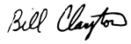  Field Representative’s Signature:  |  | Date: 3/20/2018
Reviewed by: Stephen Walker, P.E. |  |  |  |  | Reviewer’s Signature: |  | Date: Click here to enter a date.

Photography Log
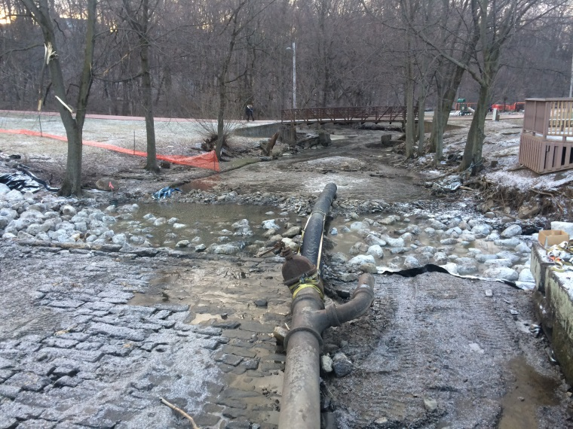 | 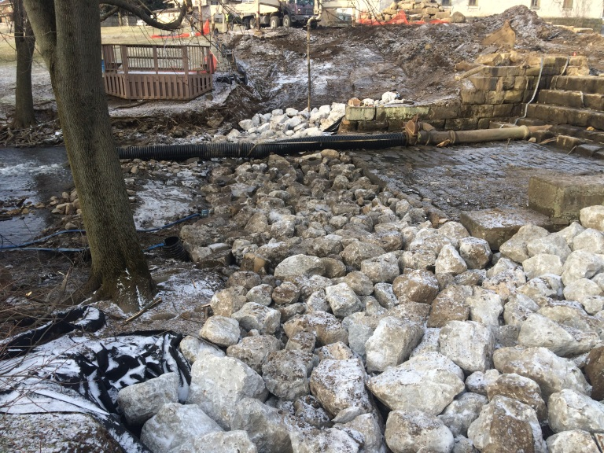
Location: Standing on spillway looking downstream  Description: Riprap previously placed downstream filled in with silt, and was subsequently removed and replaced except under drain. Photo taken prior to water being removed with pumps. | Location: East of downstream riprap, looking west  Description: Riprap placed over geotextile downstream of spillway and on side slopes, with two 2” pumps dewatering area.
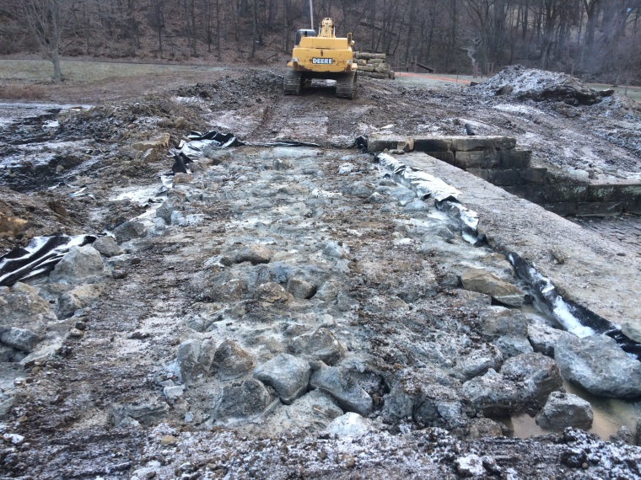 | 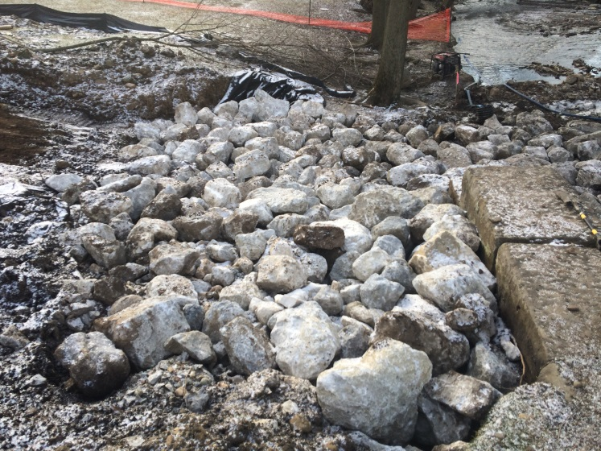
Location: Standing on west endwall looking east  Description: Grouted riprap previously placed in spillway approach channel. | Location: East of east endwall looking south  Description: Riprap placed over geotextile on east side slope.

Photography Log
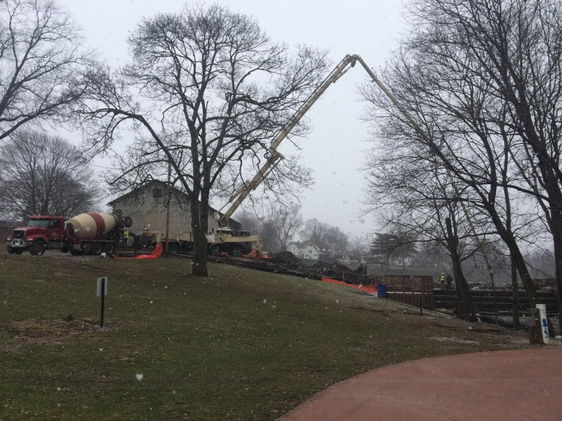 | 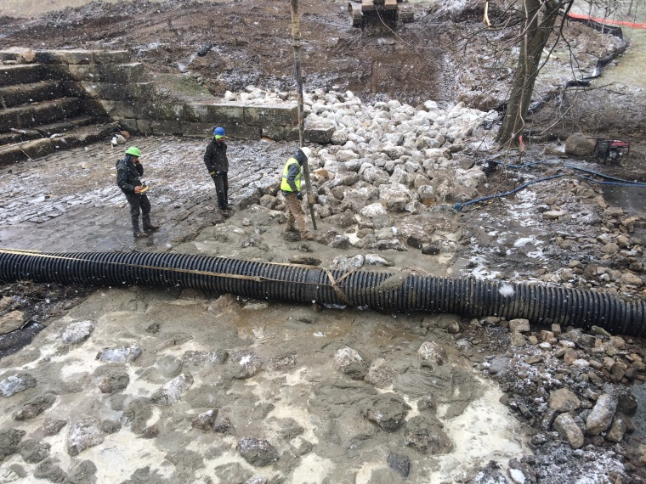
Location: Standing on pedestrian walkway looking toward gazebo  Description: Concrete truck and pump truck being used to place grout. | Location: Standing on gazebo looking at across creek  Description: Grouting riprap with pump truck hose.
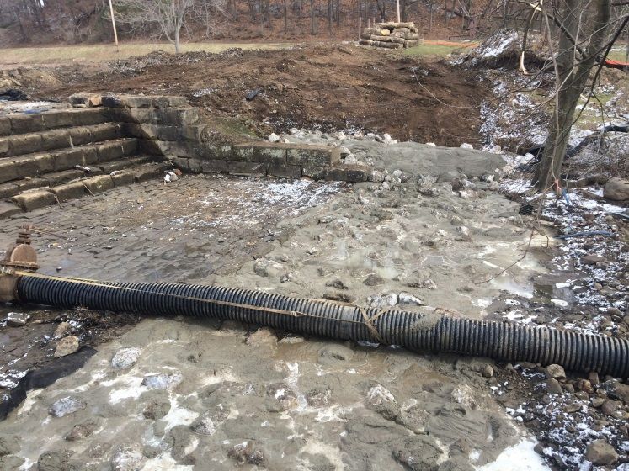 | 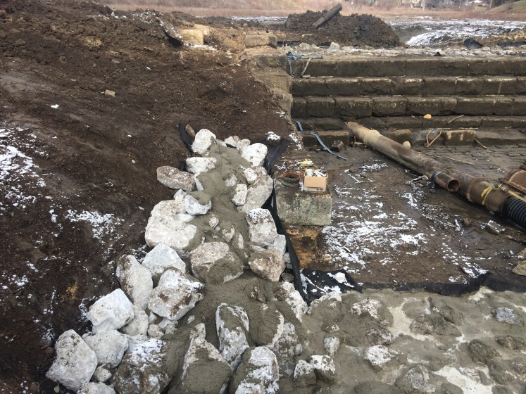
Location: Standing on gazebo looking at across creek  Description: Riprap grouted downstream of spillway and on east side slope. | Location: Standing on gazebo looking north  Description: Riprap grouted on west side slope. Grouting was light in this area due to drainage and anchor trenches to surround riprap. Area will receive more grout later.

Photography Log
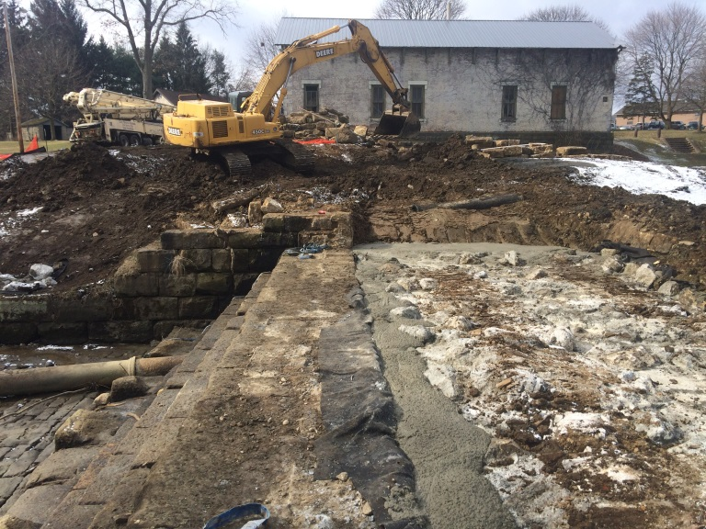 | 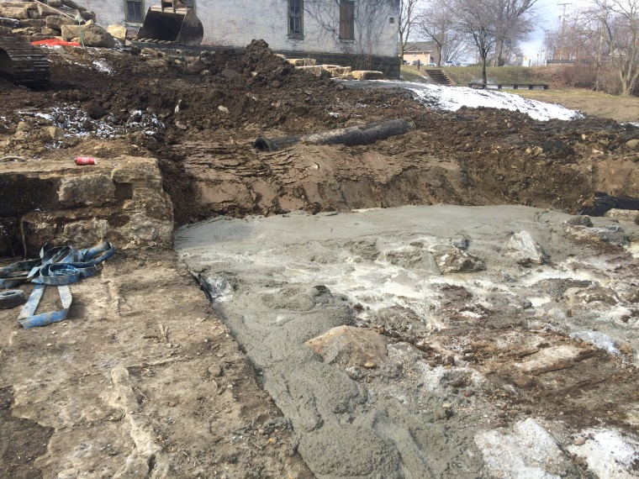
Location: Standing on spillway looking west  Description: Additional grout placed on upstream side of spillway blocks and in area that will be beneath sandstone endwall blocks. | Location: Standing on spillway looking west  Description: Additional grout placed on upstream side of spillway blocks and in area that will be beneath sandstone endwall blocks.
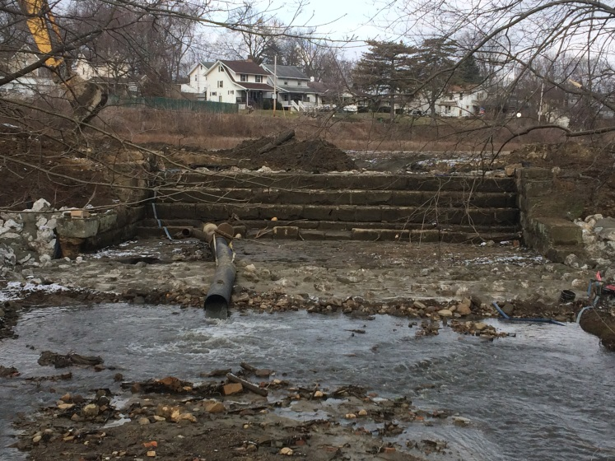 | 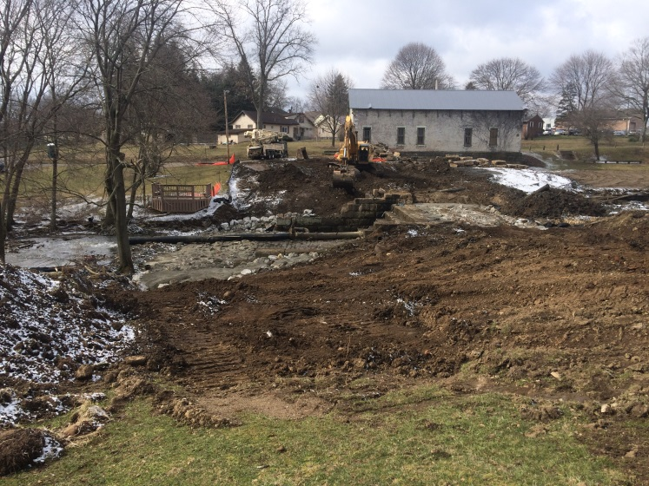
Location: Standing on pedestrian bridge looking at spillway  Description: Grouted riprap below spillway. | Location: Standing east of dam looking west  Description: Riprap grouting complete. Site conditions prior to AECOM leaving today.

